**JAVA NOTES**

**PROGRAMMING LANGUAGE**

* Medium of communication between human and machines

**TYPES**

1. **Low Level ->** That can be understandable by machine e.g.->binary.
2. **Mid Level->** Which has a few keywords called mnemonics, we need assembler to convert mnemonics into machine understandable language.
3. **High Level->**Easily understandable by humans JDK

JRE

Src.java 🡪compiler 🡪src.class (bytecode) 🡪 JVM (java virtual machine)

JVM

compiler

* JVM (java virtual machine) -> converts bytecode into machine understandable language
* JRE (java runtime environment) -> contains JVM and libraries
* JDK (java development kit) -> JRE and compiler
* Compiler-> Runs the whole code at once and givers all errors during compile time
* Interpreter->Runs the code line by line and gives one error at a time during runtime

**Features of java**

1. Platform Independent
2. Secure (we cannot get the actual memory address)
3. Muti-threaded
4. Supports OOPs
5. Open source

**Structure of Java Program**

class <classname>

* We can either declare or initialise something in a class

**To execute any java program**

1. Javac filename.java (src to compile)
2. Java classname (bytecode to jvm)
3. Java <filename>.java ->can directly run program

* To create a class file, it is not mandatory to have a main method
* Class name and file name should be same (conventional not rule)
* Compiler will create one class file whose name will be same as class name
* To run any java program MAIN METHOD is required

**Introduction to main method**

class Demo {

public static void main(String [] args){

System.out.println(“haha”)

}

}

**TOKENS**

* Smallest unit in any programming language

1. Keyword
2. Identifier
3. Literals
4. Variables
5. Operators

**1.KEYWORD**

* Predefined values that are understandable by java compiler.(50+)

**2.IDENTIFIER**

* Name given to the java components
* Class, variable, method, interface, enum

**Naming convention**

* Identifiers cannot start with numeric value
* Only _ and $ these 2 special characters are allowed while giving the identifier (they don’t have any specific meaning)
* We cannot use a keyword to create an identifier

**PASCAL CASE CONVENTION**

* Class name should always start with capital letter
* If your class name is combination of more than 2 words then first letter of each word should be capital (TextBook)

**3.LITERALS**

* Data used inside a program e.g. -> int a=10(here 10 is literal)

1. Number (10, 10.21)
2. Char (‘A’, length is always 1)
3. String(“hello”)
4. Boolean (true or false)

**4.VARIABLES**

* int num = 10
* Named block of memory
* Syntax🡪 datatype <variable name>;
* We can do initialisation, declaration and reinitialization (int a=10; a=20)
* We cannot declare 2 variables with same name (int num=10; int num=20; )

**#Datatypes:**

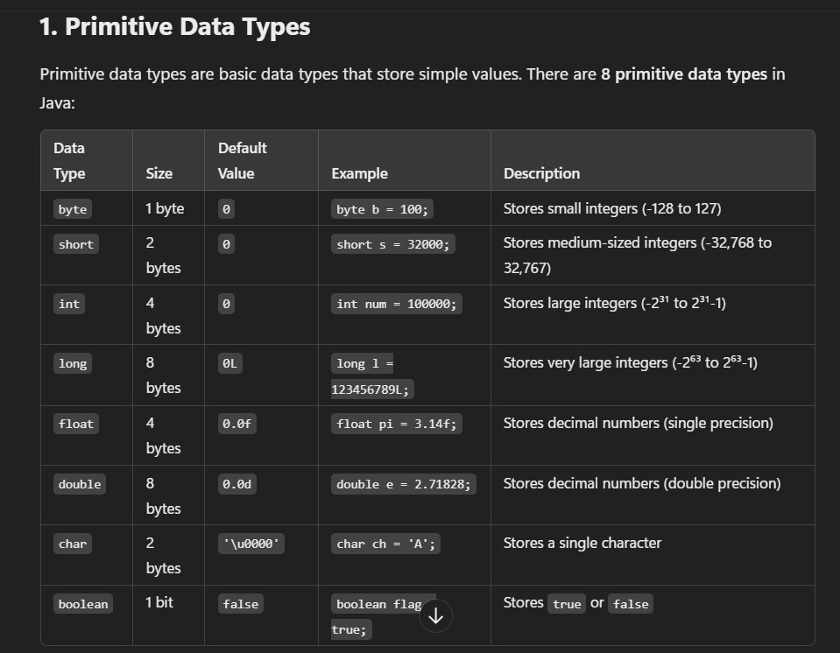

* They are predefined datatypes.
* Java doesn’t work with ASCII, it works with unicode(‘\u0000’).
* We can use 65535 characters(2 bytes) in java whereas in C/C++ we can only use 256 characters (1 byte).
* We cannot store negative value in char.
* In java size of Boolean is not precisely defined.
* We can only assign Boolean values as true/false, they are not keywords rather Boolean literals.

**4.2.Non-Primitive Datatype**

* It is a user defined datatype
* Class(string), interface, array
* Use of non-primitive datatype is to create a non-primitive variable to store a non-primitive value

**Ques🡪Can we create a variable with non-primitive datatype?**

* YES, class Demo{} Demo bag; we can store 1.null 2.object of bag

Non-primitive Non-primitive variable

**#Scope:**

**Local Variable**

* Variable created in any other block than class block

**Characteristics of local variable**

* We can access local variable only inside its own block.
* We cannot create 2 same local variables inside the same locality or inside the same scope.
* For local variable default values are not there.

**5.OPERATORS**

* Operators are special symbols that have predefined task.

**Expression🡪**Combination of operator and operand.

**Precedence 🡪** Priority of execution.

**Associativity 🡪** Direction of execution.

**5.1.Arithmetic Operators**

* +, -, *, /, %
* ‘+’, It will perform two tasks
  + - When both operands are numbers then it will perform addition.
    - If one of the operands is string it will perform concatenation.

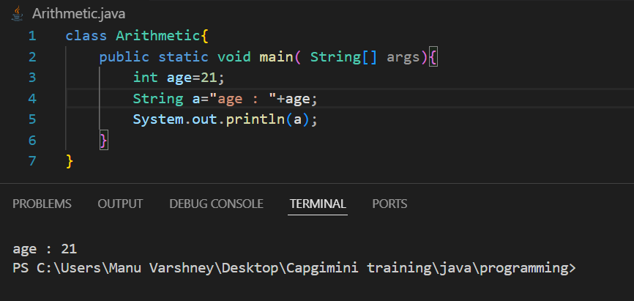

**Number + Boolean = compile time error**  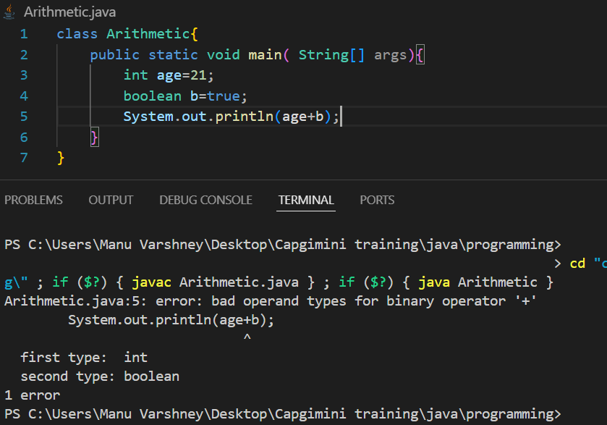

**String + Boolean = Concatenation (Boolean will be converted into string)**

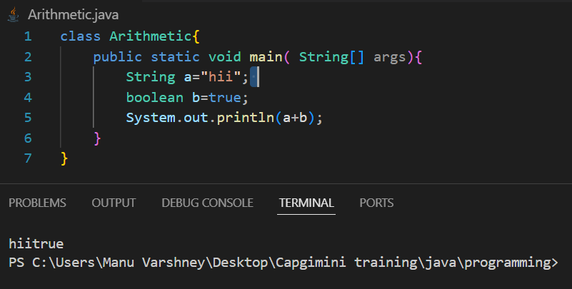

* **From uppercase to lower case +32 and vice versa.**

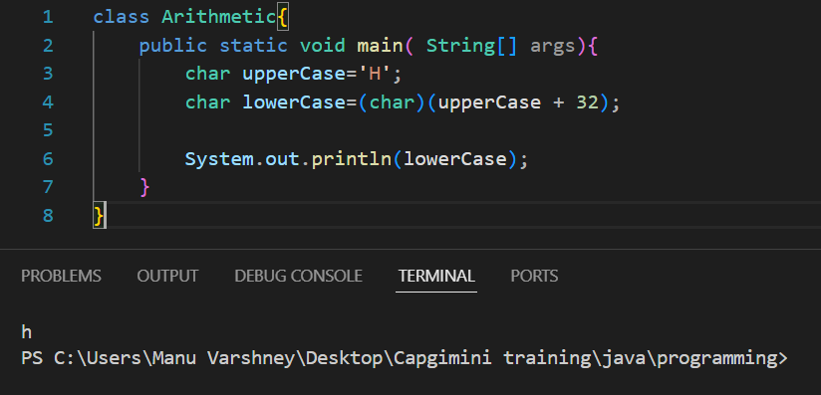

**5.2.Realational Operators**

* >, <, >=, <=, ==, !=.
* They always return Boolean value.

**5.3.Logical Operators**

* &&, ||, !
* They only work with Boolean value. 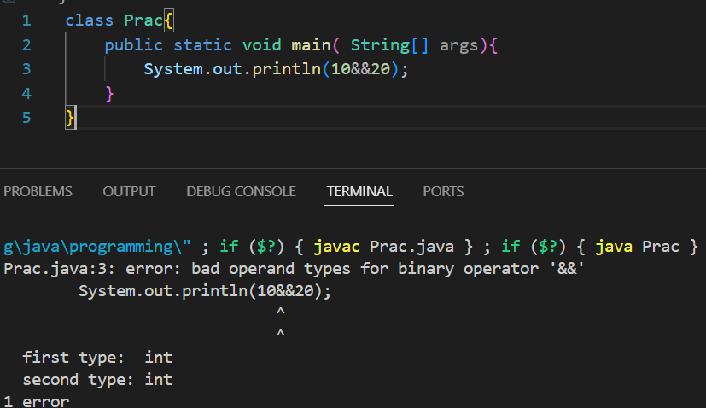

**5.4.Conditional Operators**

* ?, ; (ternary operator)

false

* Condition ? exp/value : exp/value

true

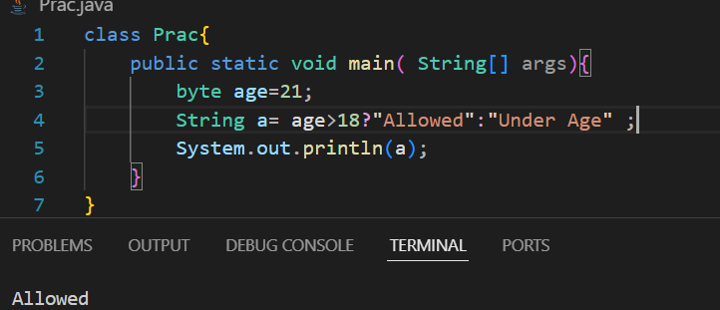

**5.5.Increment & Decrement Operators**

* ++, --
* We can only use them with variables(not with constant values).

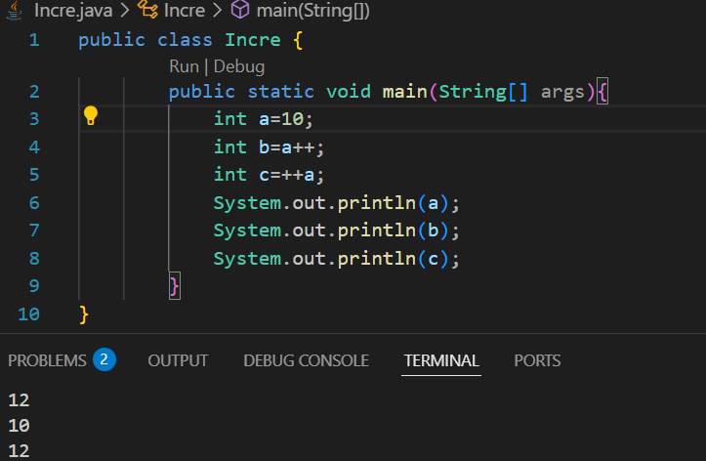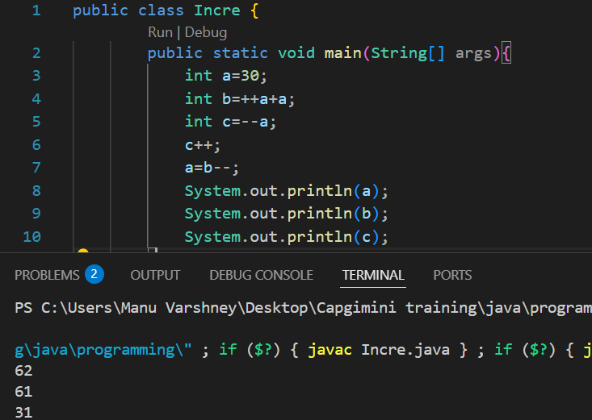

* **Special case🡪 If we post increment or decrement a variable and store it in the same variable then its value will remain the same .**

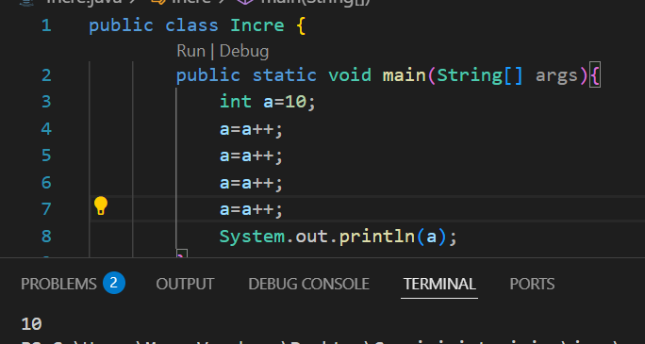

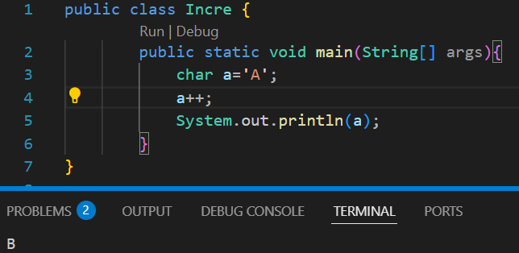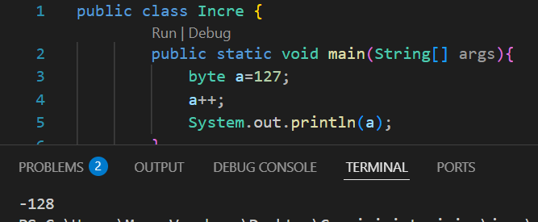

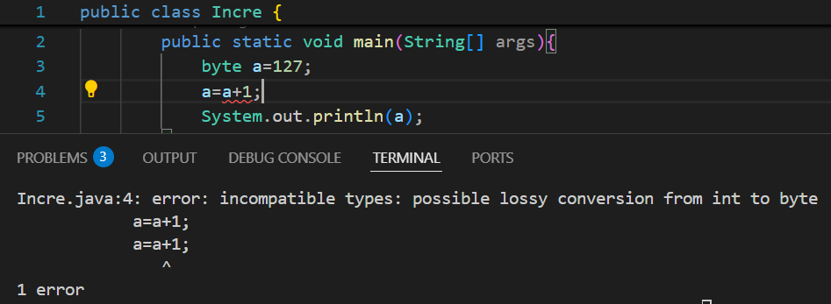

**5.6.Compound Assignment Operators**

* +=, -=, *=, /=
* Combination of arithmetic and assignment operators.

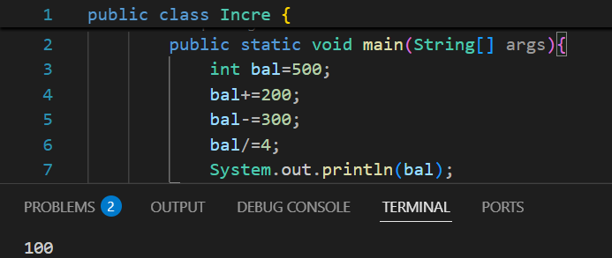

* **In compound Assignment operator we will not get error while performing any arithmetic operation on byte as it converts the result into its respective form**

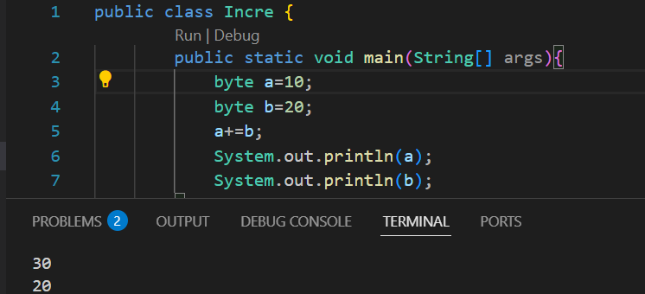

**Widening🡪**

* It is performed to convert smaller datatype into larger e.g.->int to double.
* It can be performed implicitly as well as explicitly.

**Narrowing**🡪

* Converting large datatype into smaller datatype.
* Compiler is not allowed to do narrowing **because of data loss**.
* We use Cast Operator to do explicitly type casting, <datatype>.

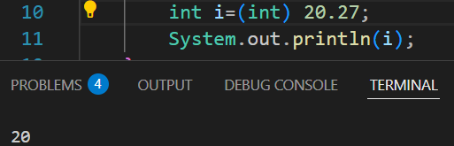

**METHOD(Function)**

* It is **set of code or block of information** that is used to perform a task.
* Modifiers return_type name(formal arguments){

----------------------

----------------------

Return statement

}

Modifiers, formal arguments and return statement are optional

* If we are not using any of the access modifier, its scope will be Default🡪Package.
* If access modifier is **Public**, the member (variable, method, or class) can be accessed from anywhere in the program.
* If the access modifier is **Private**, the member (variable, method, or class) can only be accessed within the same class in which it is declared. (We can access protected member outside the class with the help of reflection API)
* If the access modifier is **Protected**, we can only access inside the package. (We can access protected member outside the package, for that we need to use inheritance)
* We cannot create a **method with a default keyword inside a class.**
* If at the place of **Return type** there is **void**, method will not return anything, it will return the control.
* **Name+(Formal arguments)** it is called as **Method Signature**.
* **Modifiers + Return type + Method signature,** it is called as **Method Declaration.**
* **{}** are called **Method body/block/implementation.**
* **Method Declaration+ Method Block,** it is called as **Method Definition.**

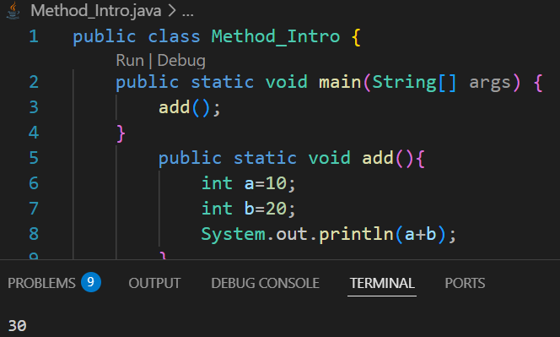

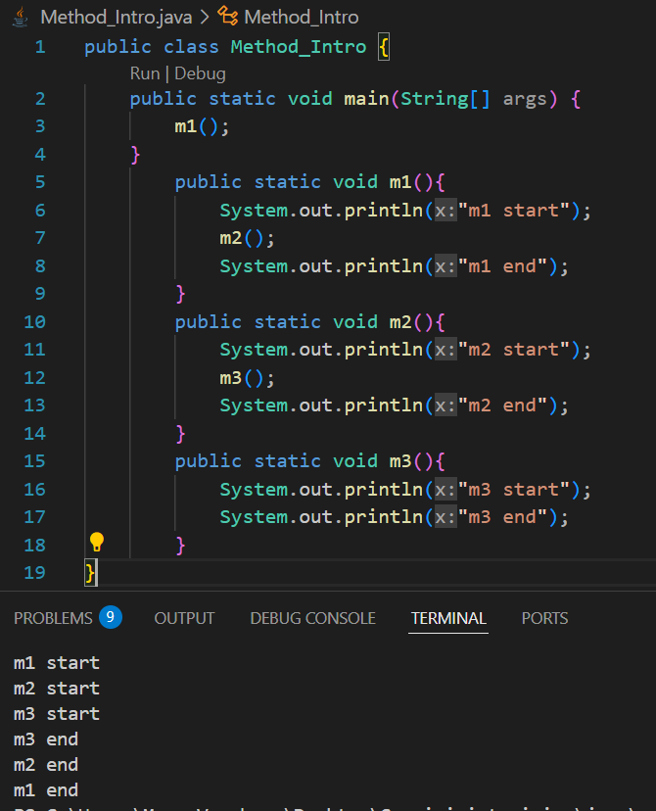

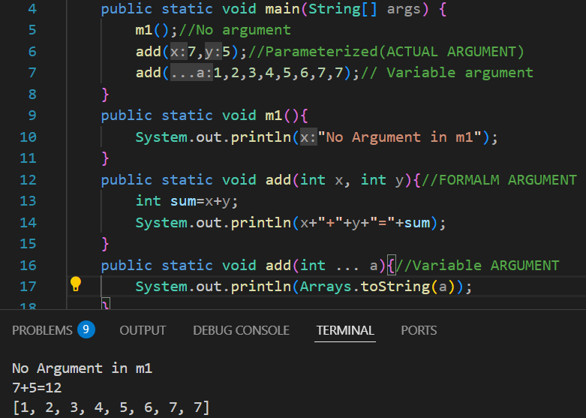

* **Variable argument🡪** It creates array when used in formal arguments, we can enter n number of values as per our requirements (e.g.--> public static int add(int … num)).
* **Actual Arguments🡪**The data that we are going to pass while calling the method.
* Length and datatype of formal and actual argument should be same.
* Whenever method with the same datatype is not present in the class, then we go for type promotion (searching for data which have higher datatype).

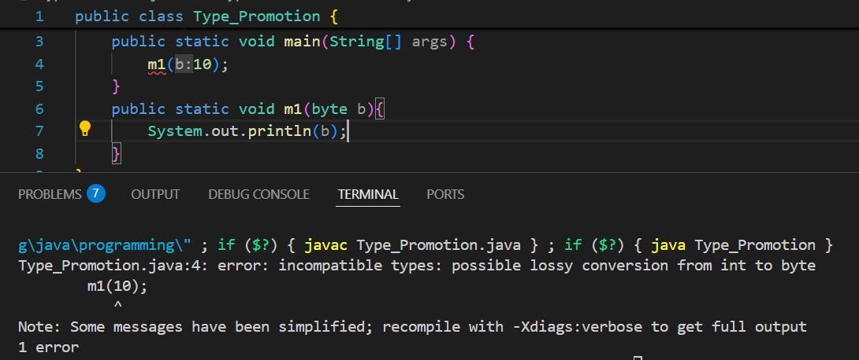

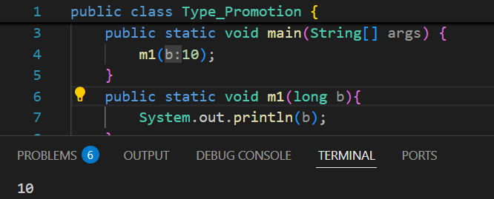

**METHOD OVERLOADING**

* If inside a class we have method with same name and different formal arguments.
* It is also called compile time or early binding because it will be done at compile time.

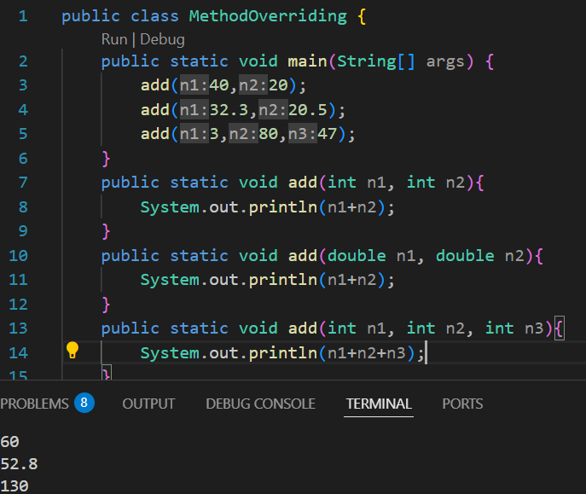

* **Println is one of the best example of Method Overloading**

**Ques🡪How to perform method overloading?**

* Method name should be same
* Formal Arguments should be different
  + Length
  + Type
  + Sequence

**Taking String Input**

* **Scanner.next()** will take input before space only(e.g.name is, only name will be taken)
* **Scanner.nextLine()** will take the whole string (but if the carriage is empty it will take empty only ass imput).
* We need to add one more Scanner.nextLine() before taking input as string**.**
* **hasNext()** will return Boolean data, it will check if data is present or not.
* Default delimiter is **“Space”.**
* We can change the delimiter by using **Scanner.useDelimiter(“:”);**

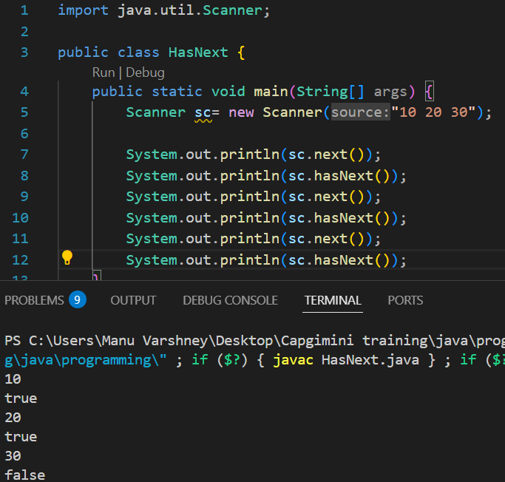

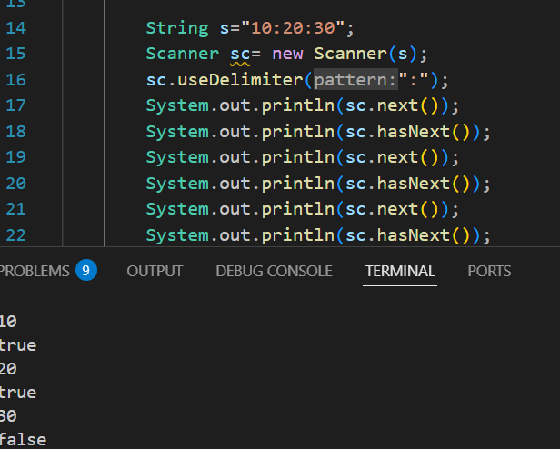

**Static Method**

* A method which has static keyword in the method declaration.

**Ques🡪How to call static method inside the same class.**

🡪1.We can call directly m1();

2.By using class name as a reference myclass.m1();

3. By object creation.

**Ques🡪How to call static method from one class to another class.**

🡪 By using class name as a reference myclass.m1();

**Non-Static Method**

* If we want to call a non static class then we have to create a class object.

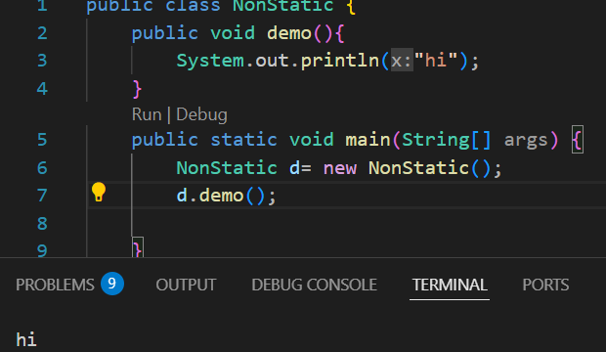

**Decision Making Statements**

* With the help of decision making statements, programmer can decide which part of code is to be executed and which part should be skipped.
* Inside **Switch** certain datatypes are not allowed.

1. Boolean
2. Double
3. Float
4. Long

**Break Statement**

* Break is a control transfer keyword which will transfer the control out of the block.
* We can use break keyword only **inside switch and looping statement**.

**Enhanced Switch (Switch as an expression)**

* There is no need of break statement.
* Default is mandatory.
* If we have multiple lines in a case then we cannot use {}, we need to use **yield** <statement>.
* Writing default is not mandatory in some cases, these scenarios are related to enum and sealed classes.
* Case value should be constant, it cannot be a variable.
* Switch is faster than else if ladder.
* Final variable is allowed as a case value
* If we have multiple cases that perform same task then we can use “,” e.g. case 1,2,3

String s= switch( ){

Case v1 -> “1”;

Case v1 -> “1”;

Default-> “0”;

**};**

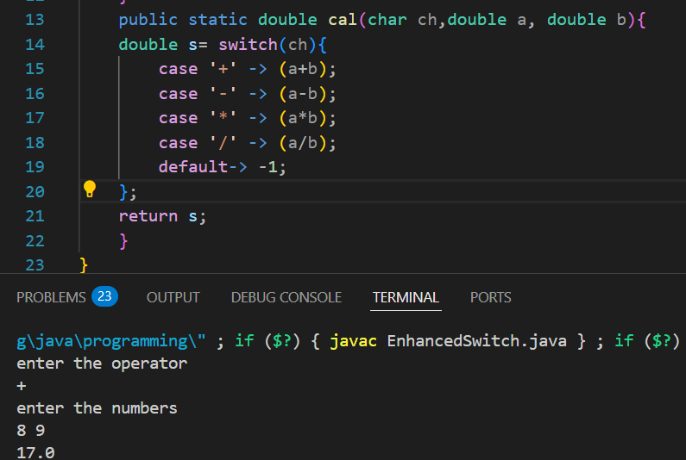

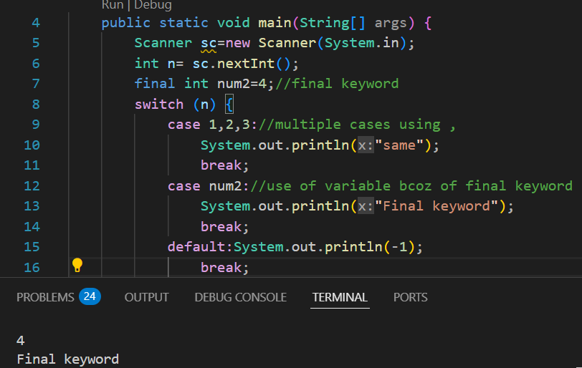

**LOOPS**

1. **While Loop**

**While (condition){**

**Statements**

**// update (not a part of syntax)**

}

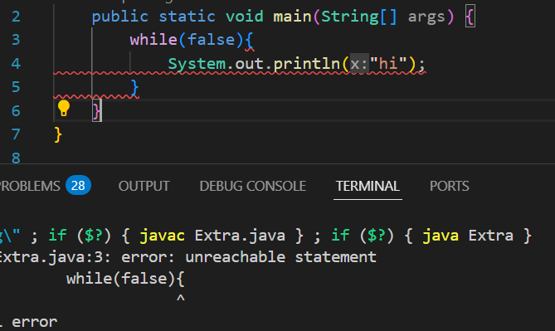

* **If we are not using any curly{} braces then we cannot declare inside a while loop**.

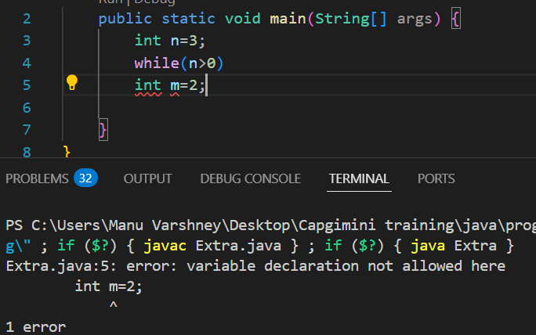

1. **For each Loop/Enhanced for loop**

**for(datatype name : array/collection){**

**Statements** }

e.g.--> int[] arr={1,2,3};

for(int a: arr){

sout(a);}

* We cannot traverse in return.

**ARRAYS**

* They are homogeneous i.e. we can only store one type of datatype.
* We cannot increase or decrease the size of array at runtime.
* Syntax 🡪 <datatype> [] <variable name> = new <datatype>[size] (int[] arr =new int[5]).
* int[] arr/ int arr[] both are correct.
* **New keyword** will create a block of memory inside heap area.
* **Arrays.equals(a1,a2)** to check whether 2 arrays are exactly same.
* **When we pass the length of array as -ve, it will give runtime error (size exception).**

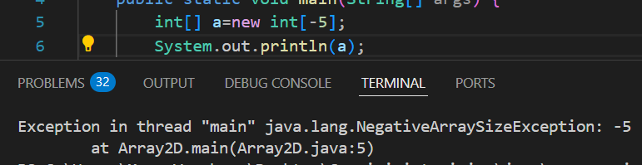

* **When we will print the address of char array it will return the array only (because println(char) is overloaded).**

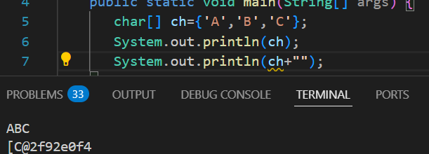

**Int[] array={1,2,3};**

**Int[] ball=array;**

**Ball[0]=1000;**

**Sout(array[0]);**

* **It will return 1000 even we have changed the value in bal array bcoz here we have copied by reference.**

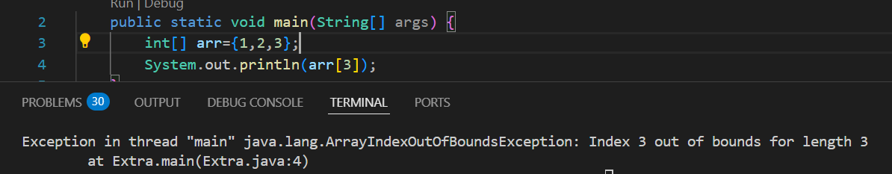

* **If we want to print array without using loops** 🡪 **sout(Arrays.toString(arr));**

**2D array**

* **Syntax 🡪 datatype [] [] variable = new datatype [rows] [cols];**
* Datatype[] [] name = { {arr1}, {arr2}, {arr3} };
* Printing directly🡪 **System.out.println(Arrays.deepToString(arr));**
* If the arrays inside 2D array are of different sizes, it is called **Jacked array**.

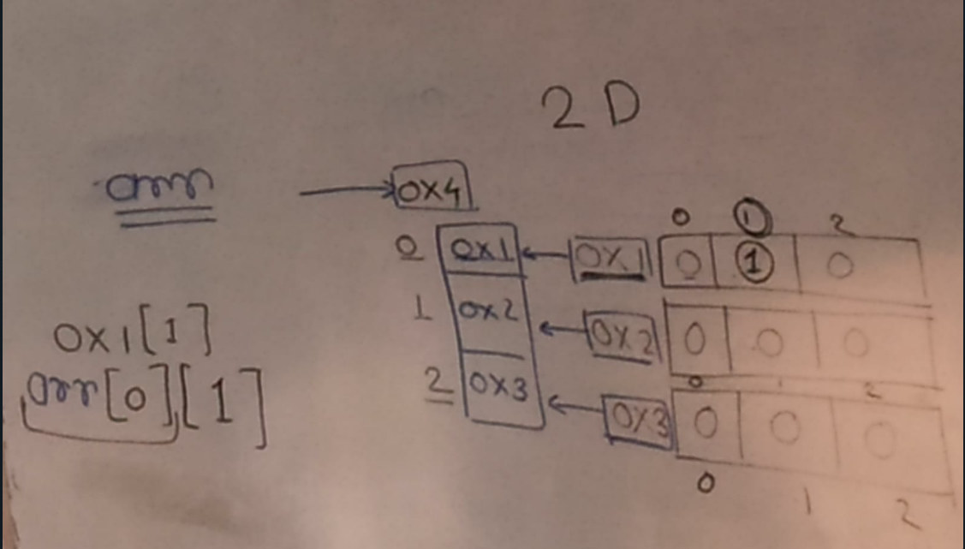

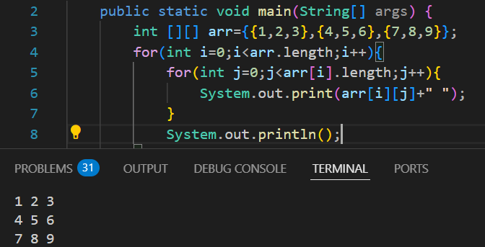

**OBJECT**

Variables

* When we want to convert real world entity into virtual world.
* In general object is a real world entity and in technical terms it is a block of memory.
* We can store heterogenous type of data (variables and methods).

Method

* Every object has two parts🡪

1. Information related to object (properties, fields and states.)
2. Action performed by the object

* If we want to create an object, we need to first create a class.
* **Class**

1. To execute a program
2. To create an object

* Syntax🡪 new constructor();
* Student s1=new student();🡪 This s1 is non-primitive variable also called **object reference variable.** Inside this s1 there will be the address of the object.

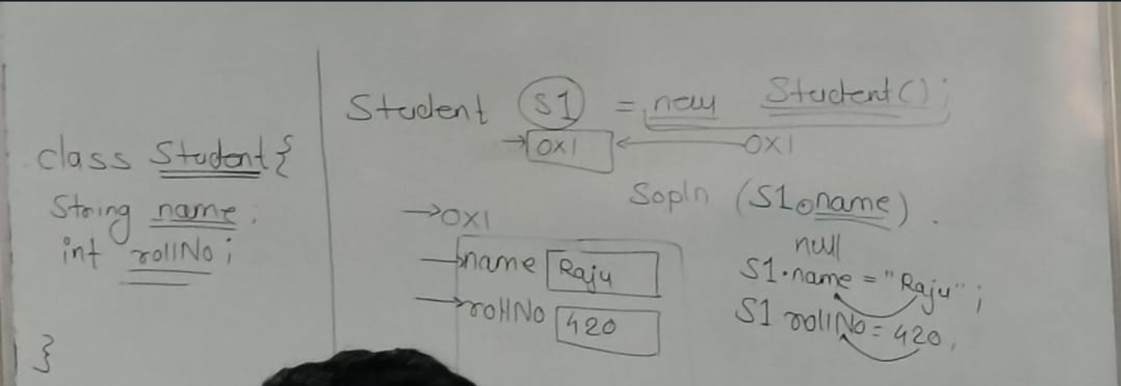

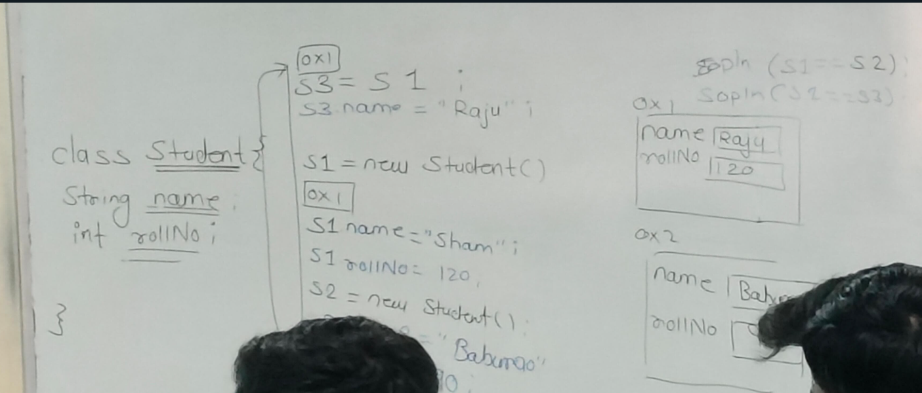

**Non-Static Variables**

* Variable created inside a class block and not prefixed by the static keyword.
* To store the properties of the object we are going to use non-static variable.
* It will get loaded for every object creation.

**Constructors**

* It is a special member of a class which will load all the non-static variables and methods into the object.
* Syntax🡪 <**access modifiers> <class name> (parameters){}.**
* There is **no return type** in constructor otherwise it will become a method.
* **Default Constructor🡪**Wherever a programmer fails to declare a constructor inside a class at that time compiler will add one no argument constructor.
* **This** is a keyword which will hold the address of currently executing object (We cannot use this keyword in static context, static method).
* We can use **return** inside constructor.

**Constructors Overloading**

* Creating different constructors inside a same class with different parameters.

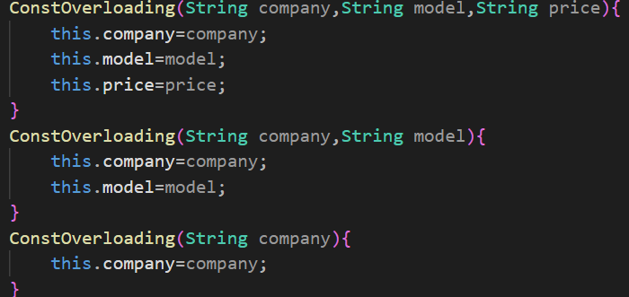

**Constructors Call Statement**

* this()🡪We can call a constructor in the same class.
* RULE 1🡪 It should be the first statement inside a constructor.
* We can use only one this() call statement inside a constructor(if we try to use more statement it will violate the first rule).
* RULE 2🡪Recursive constructor call is not allowed in java.
* We can use (n-1) this() call statement inside a class.(n= number of constructor)
* RULE 3🡪 This() call statement can only be used inside a constructor.
* **Constructor chaining**

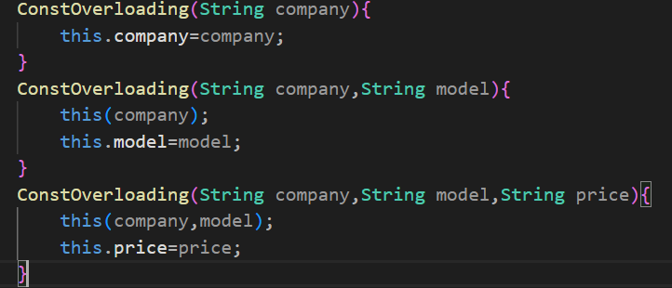

**Non-Static Method**

* The method which is created without static keyword.
* This method will be loaded inside the object.
* It will be loaded for every object creation.
* Static method will be loaded inside the static area and if you want to access non-static variable, we need address. That’s why we use non-static method inside same class.

**Non-Static Initializer/Block { }**

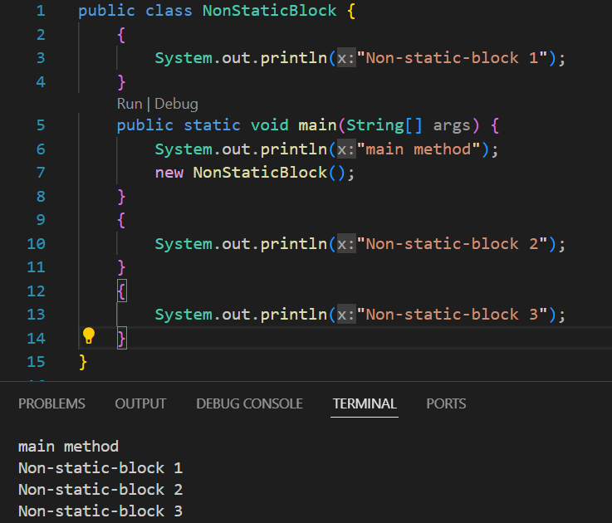

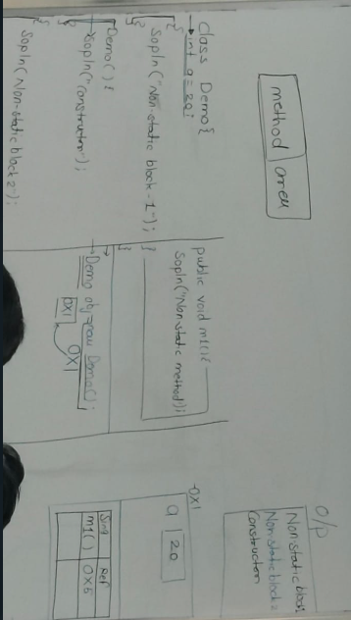

**1.Variable will be loaded**

**2.Method will be loaded**

**3.Initialization will be done**

**4.Execution from top to bottom**

**5.Constructor**

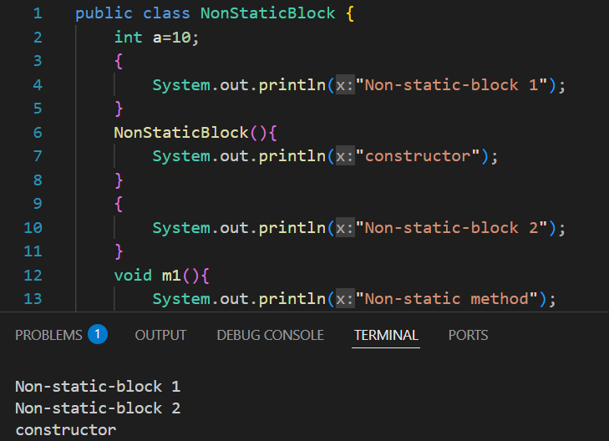

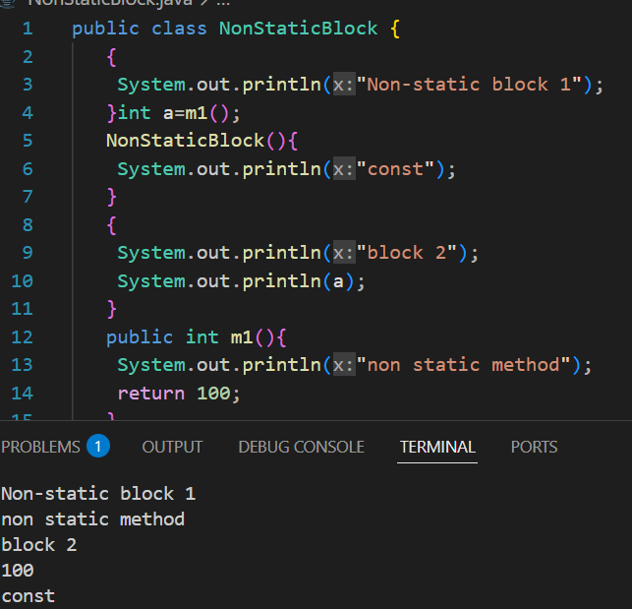

**Static Members**

1. Variable
2. Methods
3. Initializer/block🡪Block created inside a class block, prefixed by static keyword. It will be executed during the class loading process.

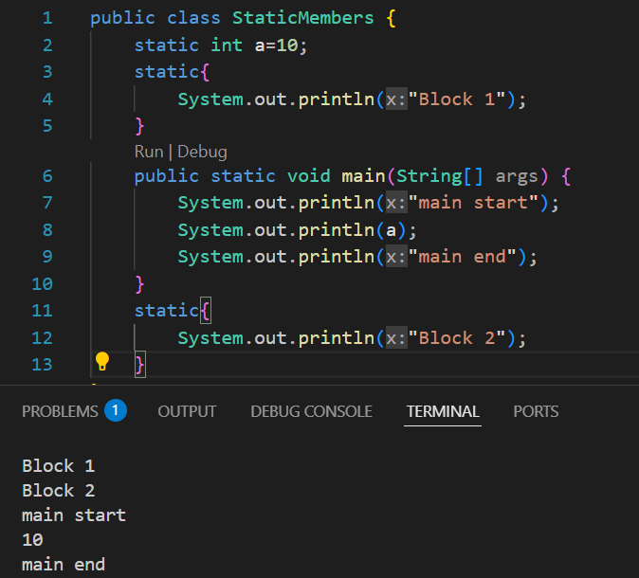

**Class Loading process**

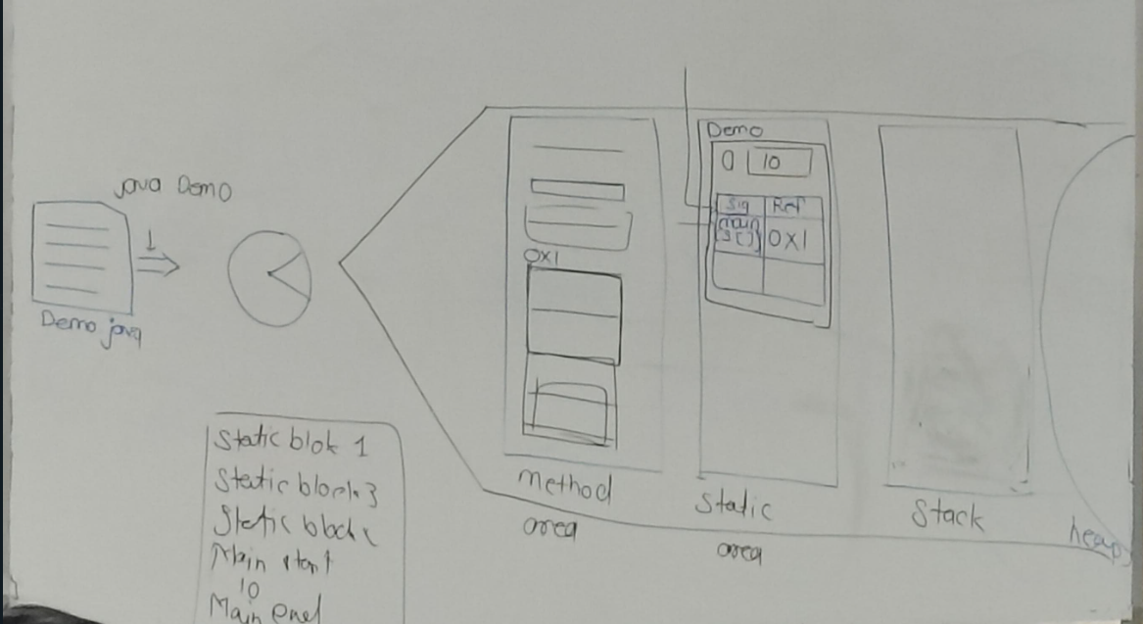

**Java runtime memory description**

1. **Method area🡪 Also known as course segment. All the code will be loaded inside the method area.**
2. **Static area🡪 All the static members will get loaded inside the static area. One block of memory will be created inside the static area, it will have same name as the class name.** 
   * 1. **Static variables will get loaded.**
     2. **Method will be loaded in table format in the form of Signature and Reference.**
     3. **Static blocks will get executed in top to bottom order.**
     4. **After that JVM will search for main method inside that class.**
3. **Stack area🡪Inside stack execution will take place.**
4. **Heap Area🡪 Every object will be created inside heap area.**

**Object Oriented Programming**

* It is a programming paradigm that is the way of designing an application.
* Another paradigm- Procedural Programming (e.g. 🡪 C).
* Object oriented will follow bottom-up approach but the procedural will follow top-down approach.
* Java is not 100% object oriented because 🡪

1. **Primitive datatypes 🡪** It **supports primitive data types** (e.g., int, char, float, etc.), which are not objects
2. **Static members🡪** It has static methods (e.g., Math.sqrt()) that can be called without creating an object. It allows direct access to static members using class names instead of objects.
3. **We cannot do operator overloading in java.**

**4 Pillars of OOPs🡪**

1. Encapsulation
2. Inheritance
3. Polymorphism
4. Abstraction

**1.Encapsulation**

* Wrapping the properties and behaviour of an object together.
* Encapsulation is used to**hide**the **internal implementation details of a class**. This technique ensures **data protection, security, and flexibilit**y in Java programming.

**Using encapsulation in Java has many benefits:**

* **Data Hiding:**The internal data of an object is hidden from the outside world, preventing direct access.
* **Data Integrity/Validation:**Only validated or safe values can be assigned to an object’s attributes via setter methods.
* **Reusability:**Encapsulated code is more flexible and reusable for future modifications or requirements.
* **Security:** Sensitive data is protected as it cannot be accessed directly.

**How to hide the data:**

* Using Private access modifier, can only access inside the class
* We have two access🡪 read access and write access. To provide these access we are going to use Helper Methods.

1. Getter Method🡪 get<variable name> e.g.-> getMoney().

Return type of the getter method depends upon the variable which we are going to access.

* + - 1. Setter Method🡪 set<variable name> e.g.-> setMoney().

Return type of the setter method is void.

**Ques🡪How to create an immutable object**

**🡪**Don’t define setter method.

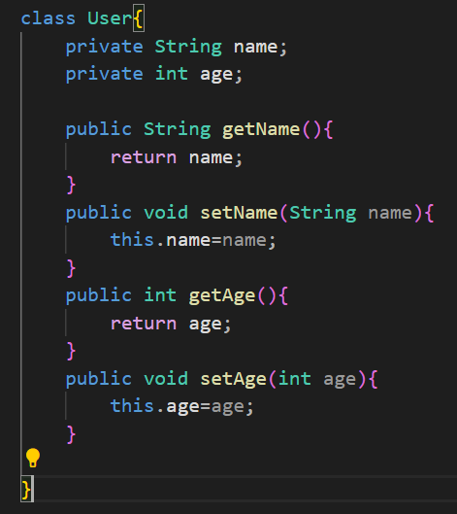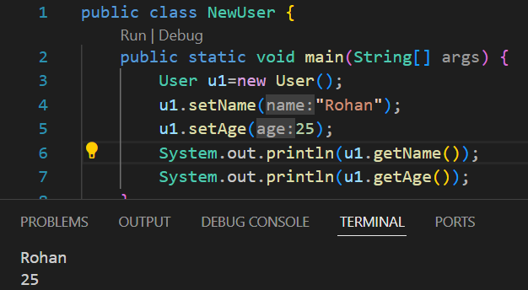

**Factory Method**

* This method will create an object of the class and will return the address of that object.
* This method should be a static method. Because we want this method to be accessed by class name.
* This is called **Factory Design Method.**

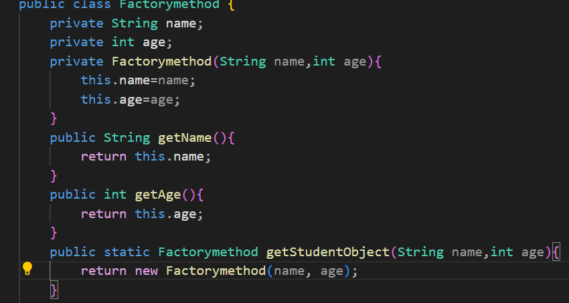

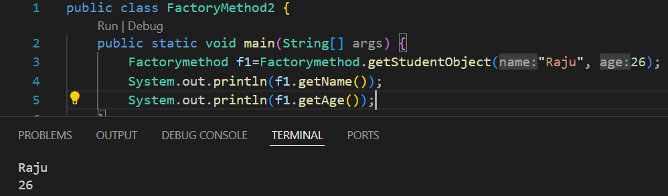

**Singleton Design Pattern**

* To create only one single object.
* It ensures that **only one instance** of a class is created throughout the application, and it provides a **global point of access** to that instance.

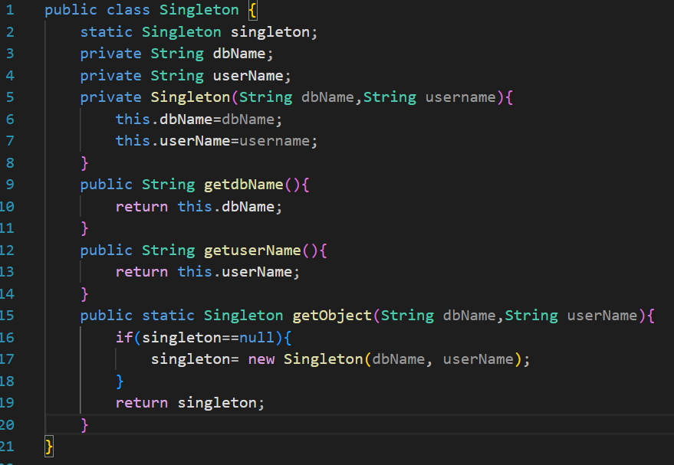

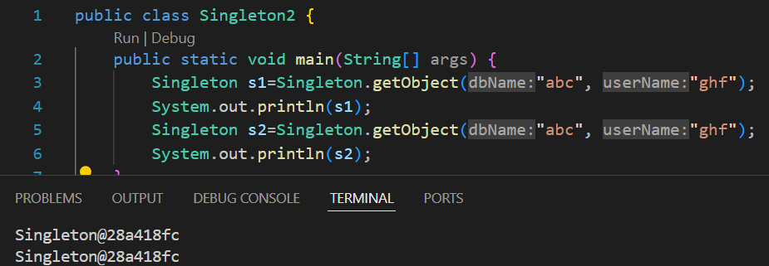

* Returning same address for both objects

**Relationship**

* Connection between two objects
  + 1. HAS-A Relationship
    2. IS-A Relationship

**HAS-A Relationship:**

* One object will act as a complete object, another object will act as a part of complete object.

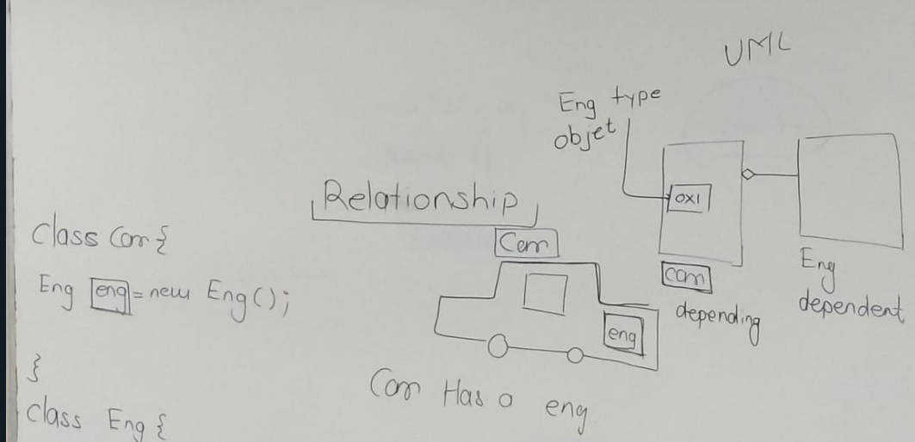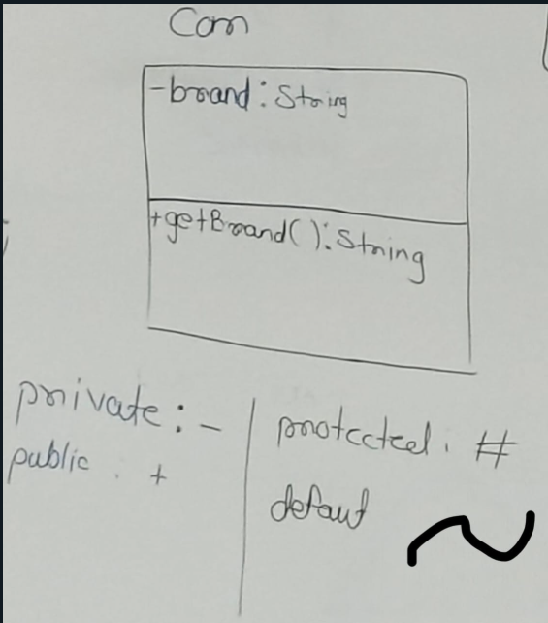

* **Composition🡪**When one object is completely dependent on another object.
* **Aggregation🡪** When one object is partially dependent on another object.

(Lazy instantiation)

* **Early instantiation🡪**This is one designing technique to create a dependent object.

(By constructor or non-static block).

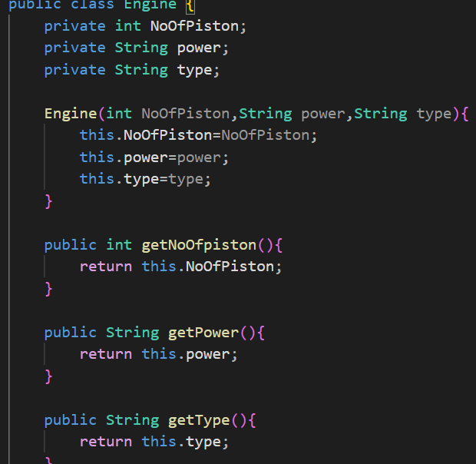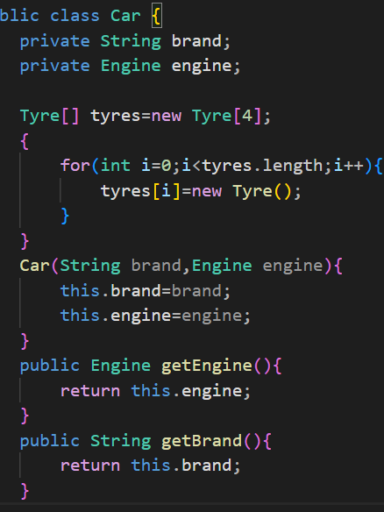

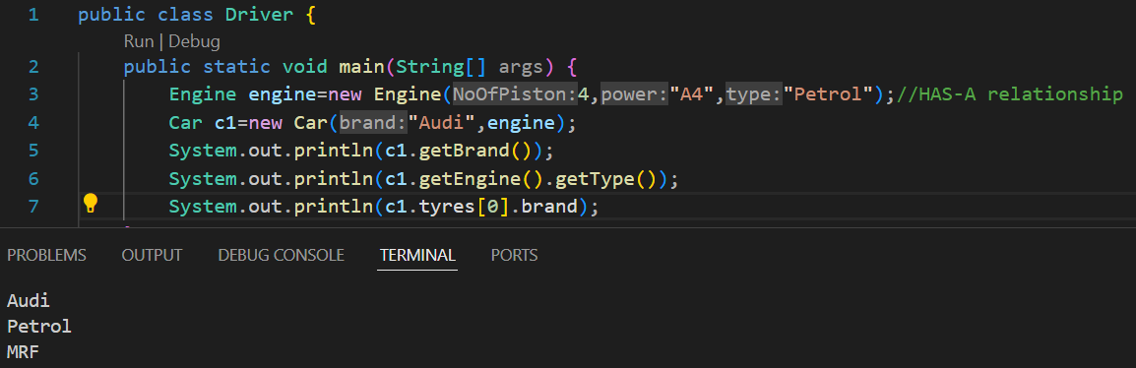

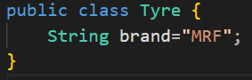

**Lazy instantiation🡪**

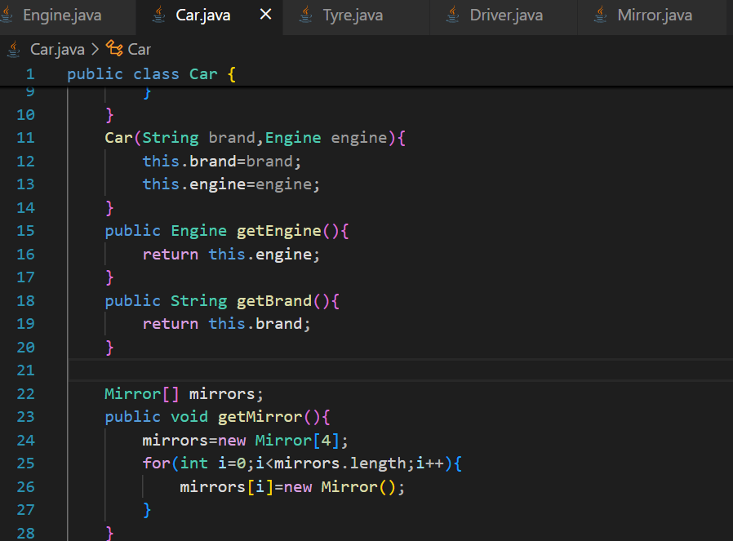

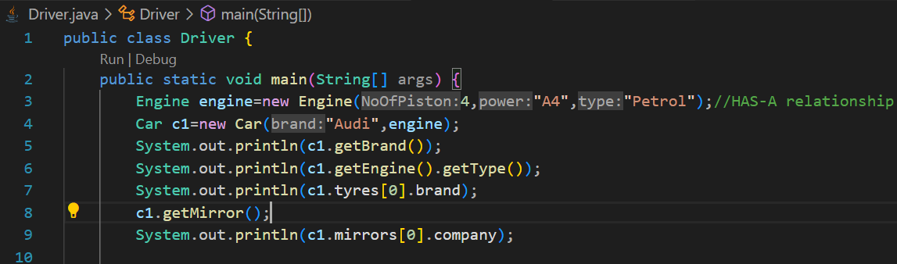

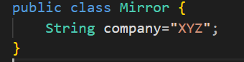

**2.Inheritance**

* It is the process of acquiring properties form one class to another class, in which one class will act as Parent class(super/base), another will act as Child class(derived/sub).
* We can acquire behaviour from parent class to child class only.
* **Constructors and initializers** will **not get inherited**.
* During the class loading process, **first the parent class will get loaded then the child class will get loaded** (because without parent child cannot exist).

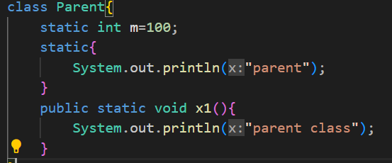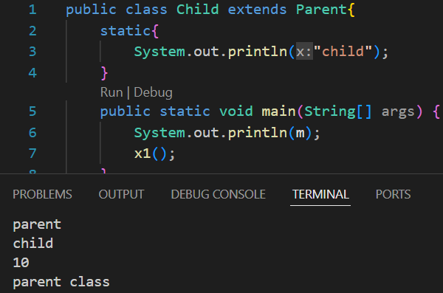

* **We have one object class which is super most class, which is parent class of every class.**

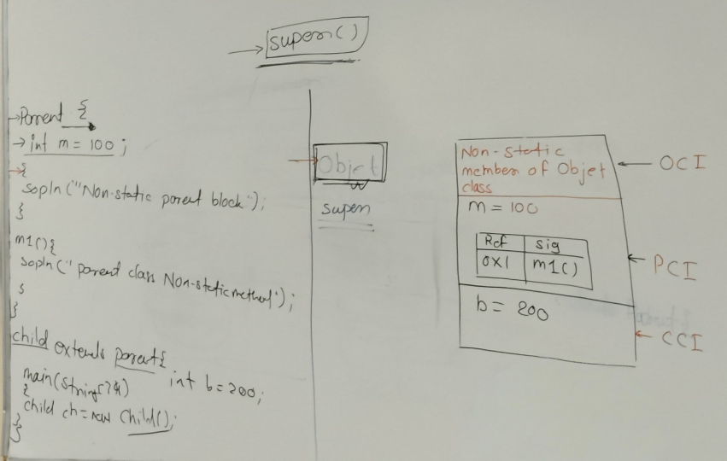

OCI🡪Object Class Instance, PCI🡪Parent Class Instance, CCI🡪Child Class Instance

**Class and Object Loading process🡪**

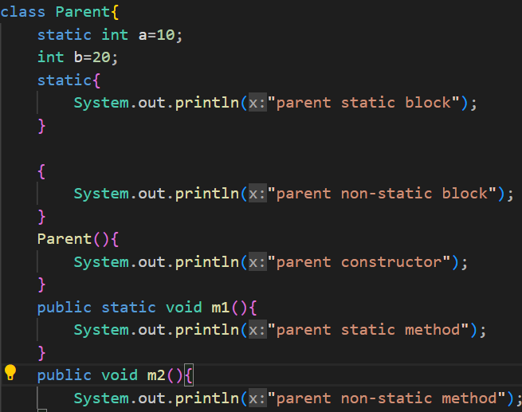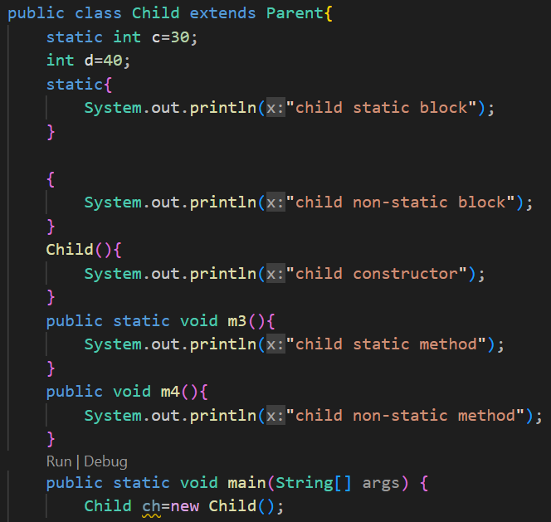

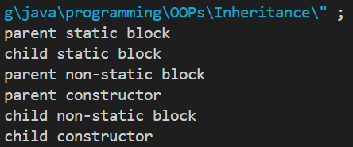

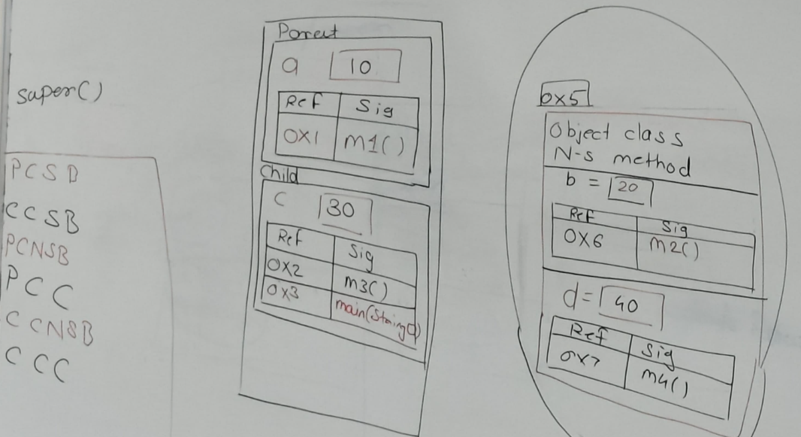

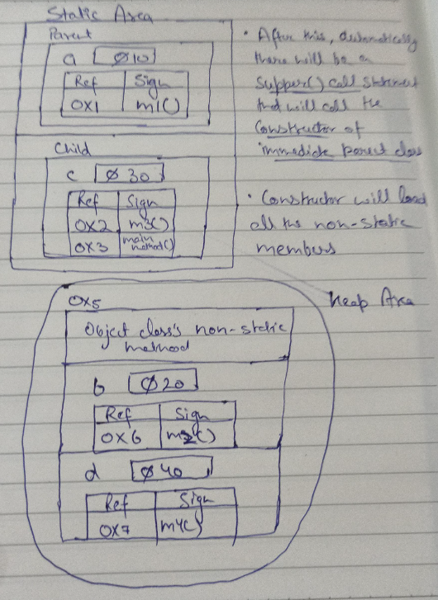 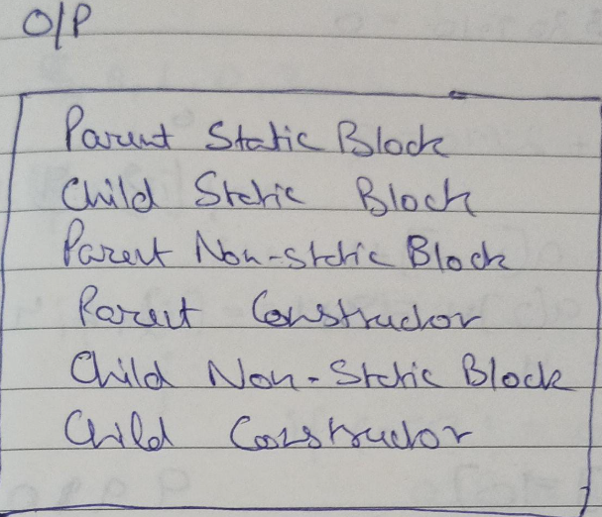

**Super Call Statement**

* It calls the immediate parent class constructor.
* We cannot use this() and super() inside a single constructor.
* It should be the first statement inside a body.
* It can be only used inside a constructor.
* Only one super() is allowed inside a constructor.

**Types of Inheritance**

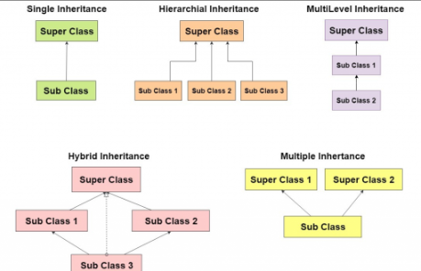

**1.Single Level Inheritance🡪**

* Every class is single level inheritance as it’s parent class is Object class(super class).
* Acquiring properties and behaviour from only one level(only 1 parent and 1 child class).

**2.Multi Level Inheritance**🡪

* A derived class will be inheriting a base class, and as well as the derived class also acts as the base class for other classes.

**3.Multiple Level Inheritance**🡪

* Acquiring properties and behaviour from more than 1 immediate parent classes.
* It is not allowed in java due to the ambiguity caused in diamond problem as which of the constructor to call.
* It can only be performed by using **Interface**.

**4.Hierarchical Inheritance**🡪

* Single parent is having more than 1 children.
* Sibling classes cannot perform inheritance.

**5.Hybrid Inheritance**🡪

* Combination of more than one type of inheritance.

**If we want to perform inheritance we have two keywords :-**

1. **Extends🡪** When parent and child both are either classes or interfaces. **You can write only one class using extends keyword.**
2. **Implements🡪**When parent is interface and child is class.

**Non-Primitive Type Casting**

* Converting one non-primitive type into another non-primitive type.

**Upcasting🡪**

* Converting Child type of reference into Parent type of reference.
* e.g. 🡪 Parent ch=new Child()
* Can be performed in both ways, **implicitly and explicitly.**
* **With upcasted reference you cannot access any child class member.**

**Downcasting🡪**

* Converting Parent type of reference into Child type of reference, using cast operator.
* e.g. 🡪 Child ch1=(Child) ch
* It can be done only **explicitly**.
* If inside child and parent class we have variables with same name and we want to access the **variable present in parent class** then we need to **do upcasting**.
* With **upcasted reference** we cannot use **properties and behaviours of child class** so we need to **perform downcasting**.

**Generalization🡪** Creating one generalized container that can store any child type of reference. Without inheritance it is not possible.

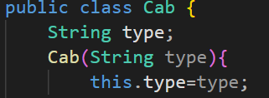 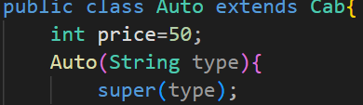

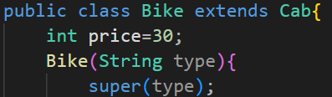 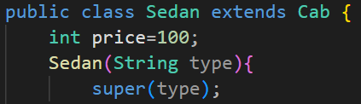

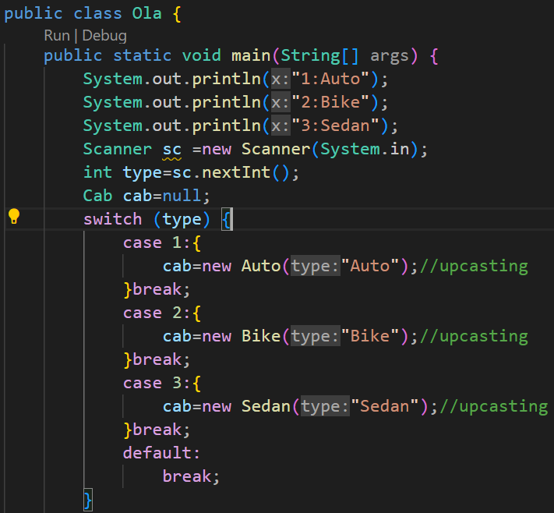

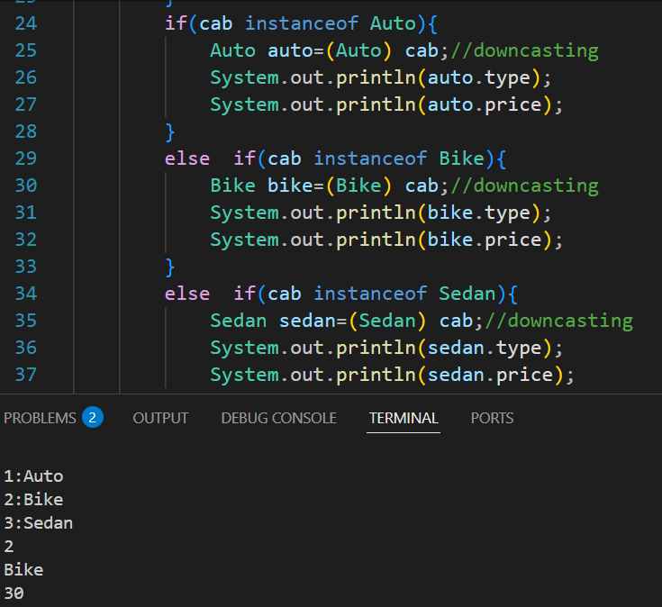

**# ClassCastException**

* When we do downcasting without doing upcasting then we will get ClassCastException because there is no instance of child class.

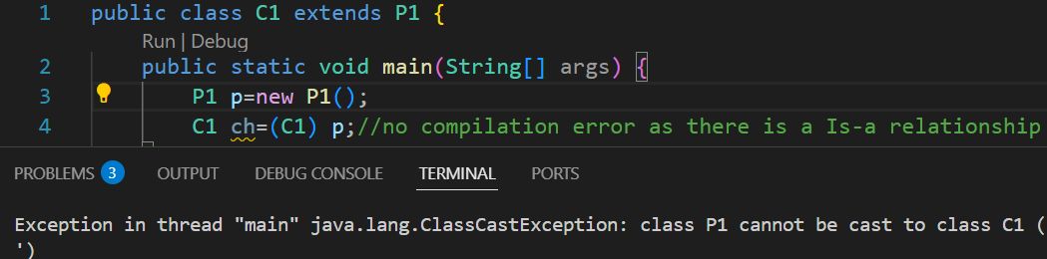

If we allow the complier to do downcast implicitly, there will be

Parent Class Instance

Object Class Instance

**no instance of child class** in the object and it will give runtime error.

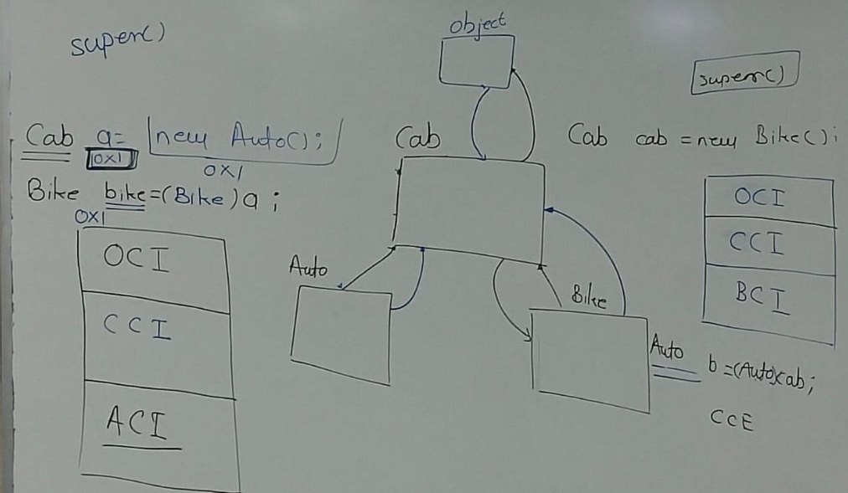

**# instanceof**

* We can use instanceof only between 2 classes which have Is-a relationship.
* Syntax🡪 variable instanceof class name.

**METHOD OVERRIDDING**

* Overriding in Java occurs when a subclass (child class) implements a method that is already defined in the superclass or Base Class. The overriding method must have the same name, parameters, and return type as the method in the parent class

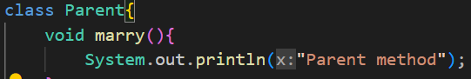cons

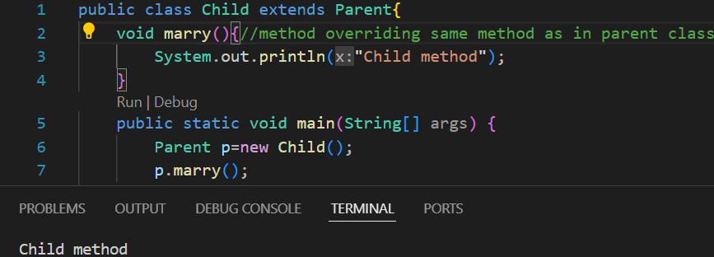

* **How to achieve method overloading?**

1. Declare the same method inside the child class and the parent class.
2. Create object of child class and perform upcasting.
3. Call the method with the upcasted reference.
4. **Method Overriding can only be achieved with non-static method.**
5. While writing the access modifier we can increase the visibility. E.g.--> default in parent class and public in the child class (Note- public is anywhere and default is inside the package).
6. Just like that we cannot reduce the visibility of the access modifier in child class.
7. If return type of the parent class is void or any primitive datatype then inside child class method it should be exactly same.

**Covariant return type🡪**We can change the return type of a inherited method but there are few conditions:-

1. Return type of parent class should be non-primitive datatype.
2. Now we can change the return type of child class method, we can write any child class name.

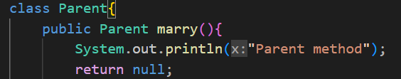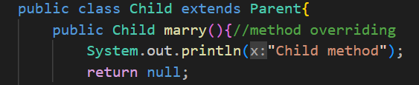

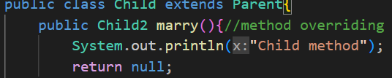

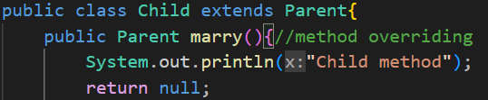

* **We cannot override a final method.**
* **If method is static in parent class it will return parent method only**

**Method shadowing 🡪In Method Shadowing which method will get called will depend on what type of variable we are creating (with static method).**

**Method Overriding 🡪In Method Overriding which method will get called will depend on what type of object we are creating (with non-static method).**

**3.Polymorphism**

* Ability of an object to perform multiple behaviours.

**4.Abstraction**

* Providing the functionality to the user and hiding the implementation from the user.
* It is performed using **Abstract Method🡪**The method which don’t have any implementation and starts with abstract keyword and end with semicolon(;).
* Abstract method is incomplete method.
* **Concrete method🡪**Method which have implementation.
* If in a class there is an abstract method then the class should be mandatory declared as abstract (because the class is also incomplete).
* Abstract class can support abstract method.
* We cannot create an abstract class object **explicitly**.
* We need to **Override** this abstract method. We need to create a child class for this abstract class.
* If inside a parent class we have a abstract method then we have only two options:-
  + 1. We can declare the child class as an abstract class.
    2. Override the abstract method.
* With the help of classes we cannot achieve 100% abstraction because every class is a child class of Object class, all the 11 methods present in Object class will be inherited inside child class.
* **Static method cannot be abstract method because it cannot be overridden.**

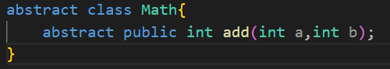

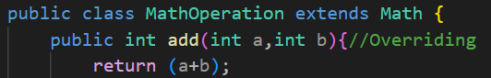

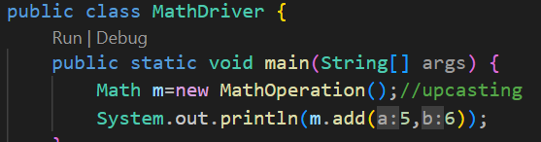

**Object Class**

**1.toString Method**

* toString method is present in object class, return type is string.

**Ques🡪What is the implementation of toString method which is present in object class?**

🡪It will return string address.

* Whenever we are going to print any object reference variable, automatically JVM will call the toString method.
* Method declaration🡪 **public String toString( ).**

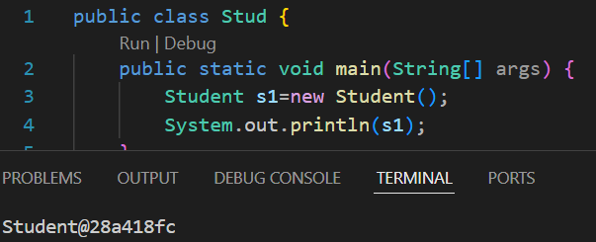

**# toString overriding**

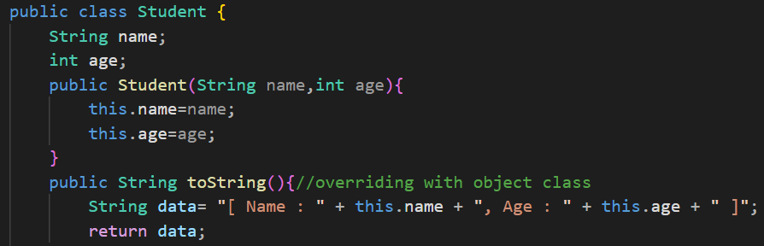

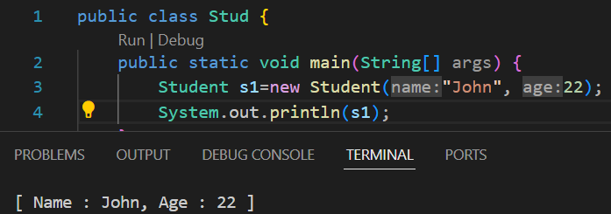

**2.equals Method**

* The equals method which is present in object class will compare the address.
* Return type is Boolean.
* Formal argument is object.

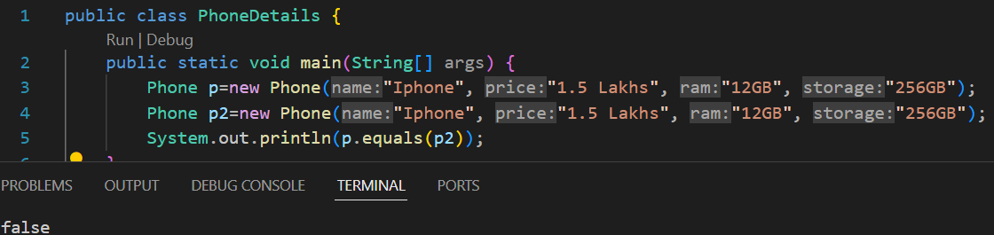

* It is returning false as the addresses of both objects are different.

**# equals overriding**

* Here the object class is the parent class of both Phone and PhoneDetails

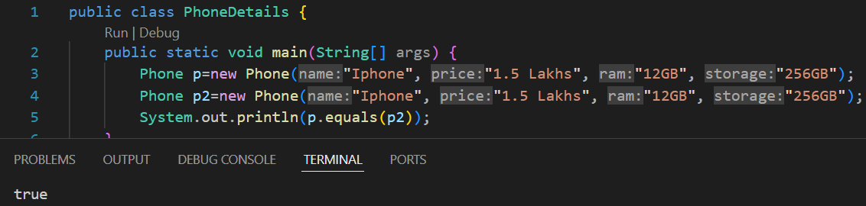

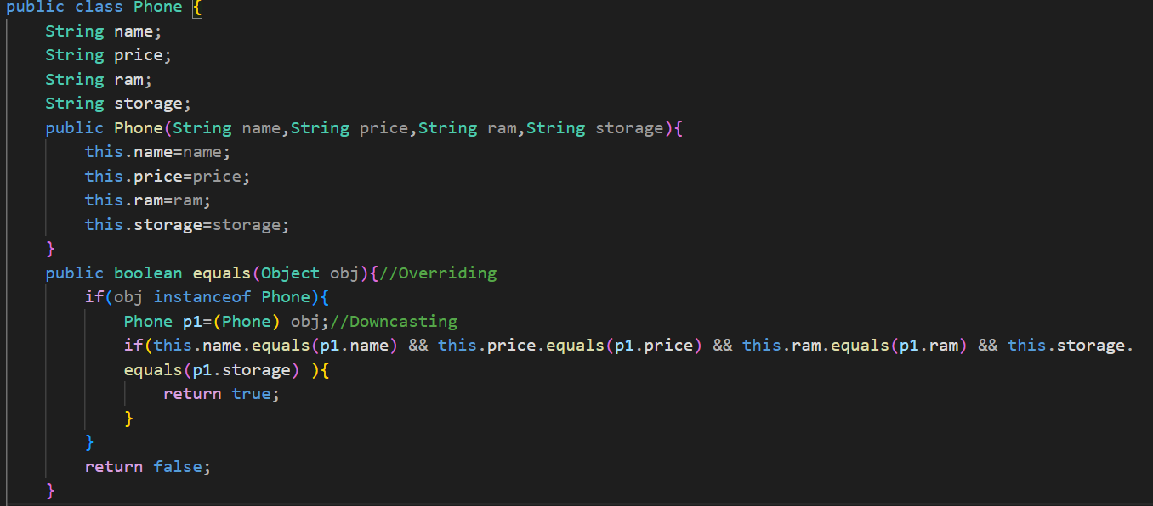

**3.hashCode Method**

Objects is a utility class which is present inside util package.

Returns unique integer value that can be positive or negative.

**Interface**

* With the help of Interface, we can achieve
  + 1. Multiple Inheritance
    2. 100% Abstraction.
* There is no constructor in interface and you cannot write one (no super call statement)
* Inside interface **we can have only** **Static Final Public variables** (even if we are not declaring public final static, compiler will do it for variables).
* Inside interface **Abstract non-static method is allowed.**
* **Static methods of the interface are not getting inherited.**
* **Class cannot be a parent of interface.**
* When we want to perform inheritance **between two interfaces then we use extends** keyword, whereas **between an interface and a class, we use implements keyword.**
* Default methods are allowed inside interface onwards Java-8.
* **Main Method** is also allowed inside interface onwards Java-8.
* **Private non-static methods are** allowed inside interface onwards Java-9.

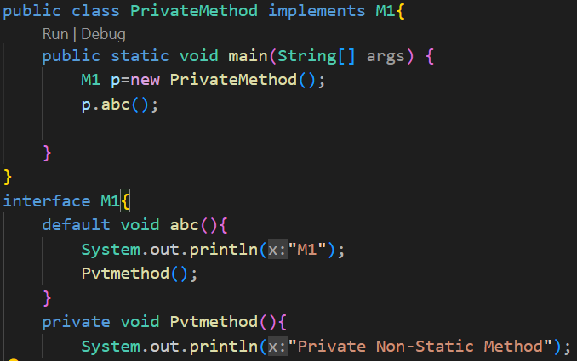

**Default Method🡪**

* + A method which is created inside interface with default keyword.
  + It is a non-static concrete method.
  + Syntax🡪 default return type name().

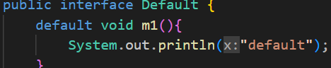

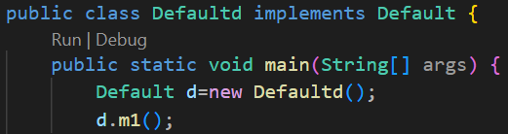

**Diamond problem**

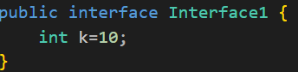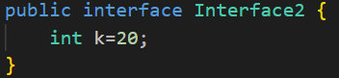

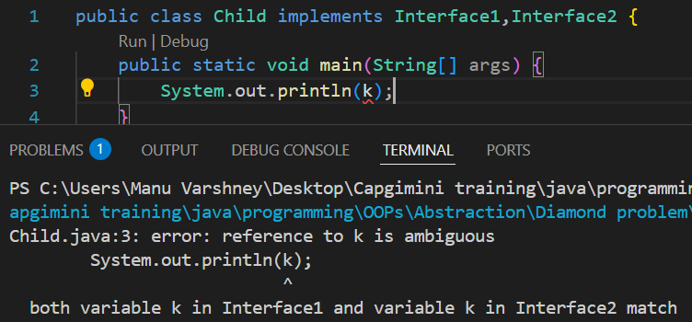

**Solution**

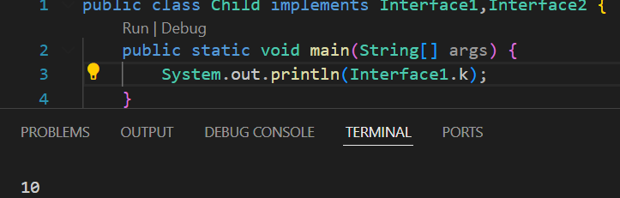

**For default method**

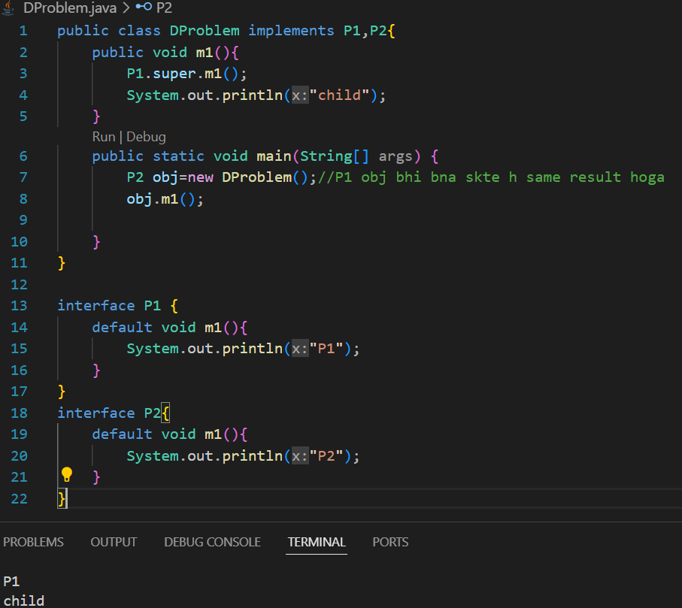

**Ques🡪** If we have a class which is inherited from 2 interfaces the how can we inherit the same class from another parent class.



**Enforced Contract🡪**

If someone says "enforced contact" in Java, they might mean **forcing a class to "contact" (interact with or implement) certain methods**, typically via an **interface or abstract class**.

Here, the contact() method is **enforced** by the Contactable interface. Any class that implements Contactable must define this method. This is a common pattern in Java — using interfaces to **enforce a contract**.

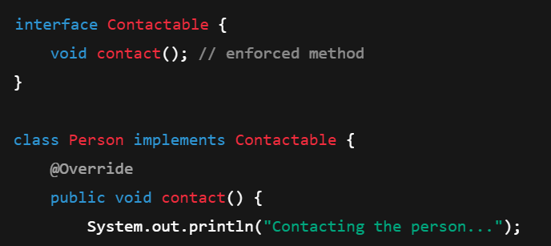

**Object Cloning**

**1.Deep copy**

* A deep copy means copying everything, including all nested objects. You get a completely independent copy of the original object, with no shared references.

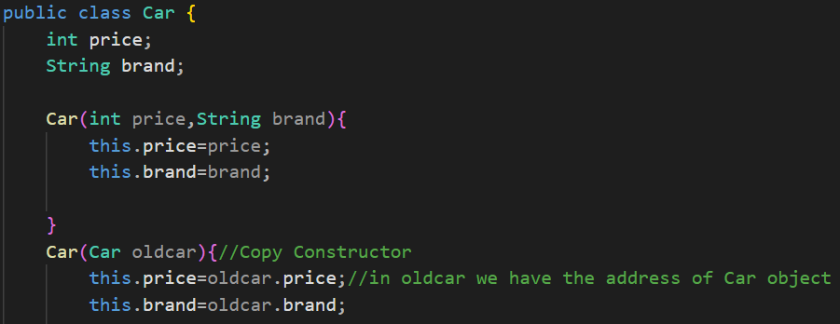

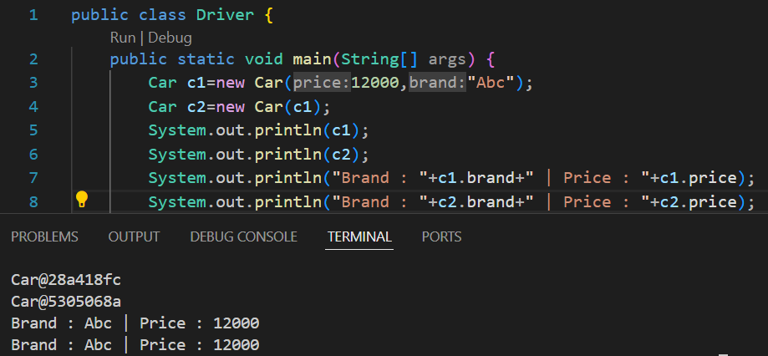**Address of new object will be different but everything will be same**

**2nd example**

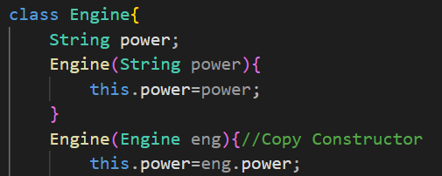

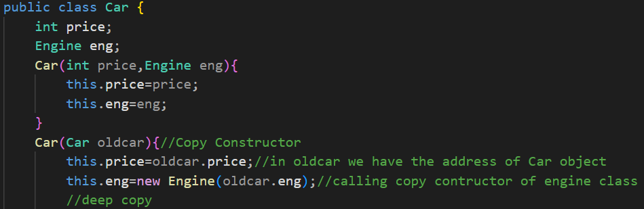

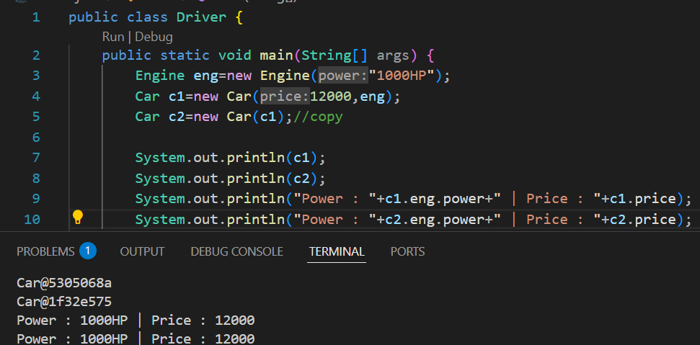

**1.Clone Method**

* In clone method by default, it performs shallow copy (copying the reference).
* We need to override this clone method to perform deep copy.

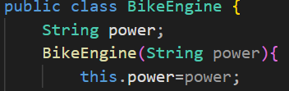

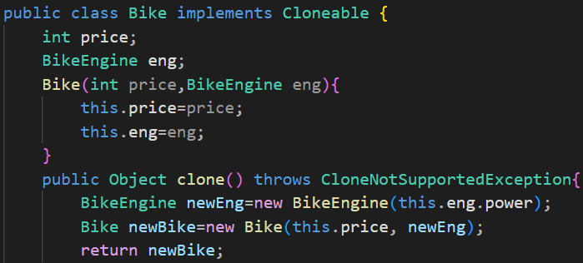

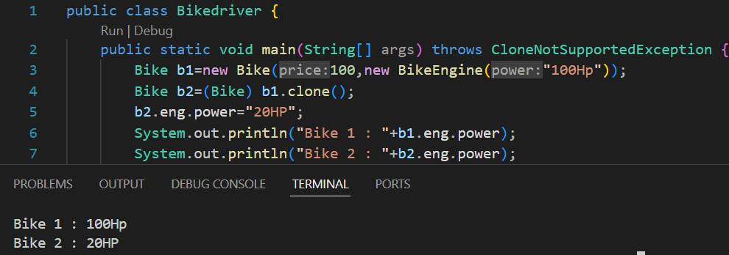

**String**

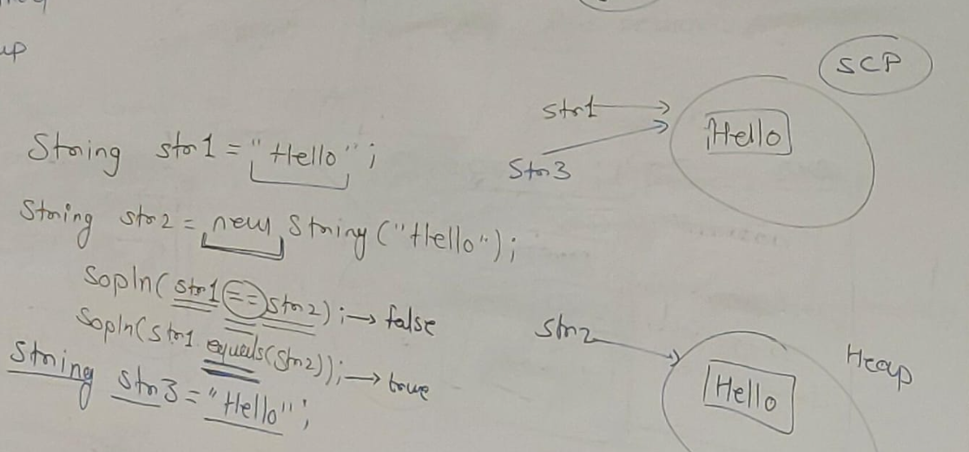

* **Scp**🡪**String constant pool**
* == operator checks the address.
* String str1 = "Hello" (created inside String constant pool).
* String st2 = new String ("Hello") (this creates an object of String class in the heap area so st1 and str2 has different addresses).
* String st3 = "Hello"; (JVM will not create an extra memory inside the SCP to save memory and point to same object)

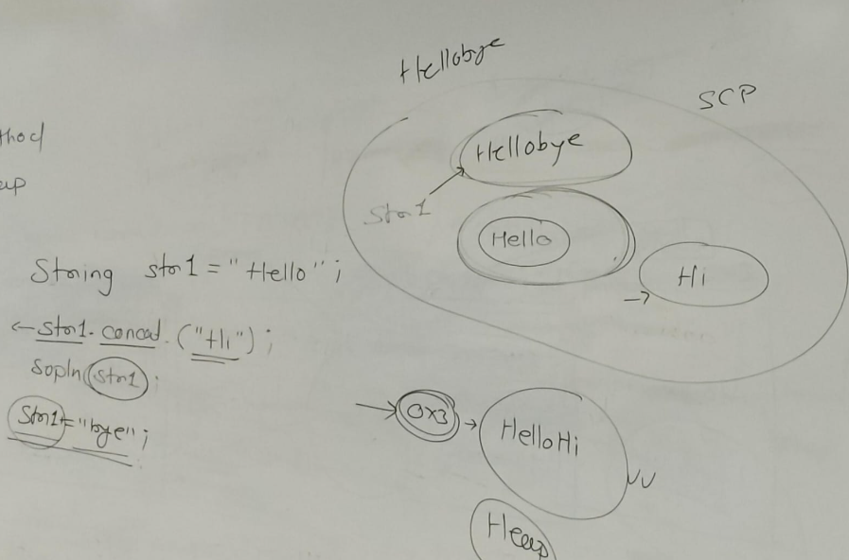

* “Hello” will be created inside Scp with reference s1.
* “Hi” will also be created inside Scp and JVM will provide internal reference.
* When we will perform s1.concat(“hi”), it will get created inside heap area as HelloHi but as we are not providing any reference to it, garbage collector will take it.

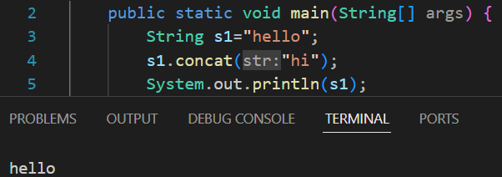

* As s1 is still have Hello it will print hello.

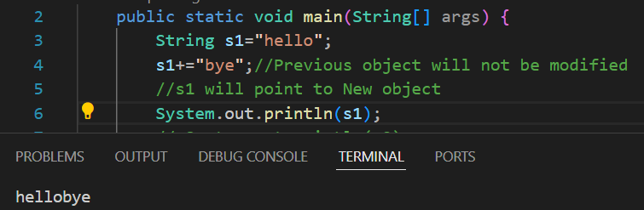

* **As string object is immutable the object will not be modified rather a new string object will be created inside Scp and s1 will now point to new object.**

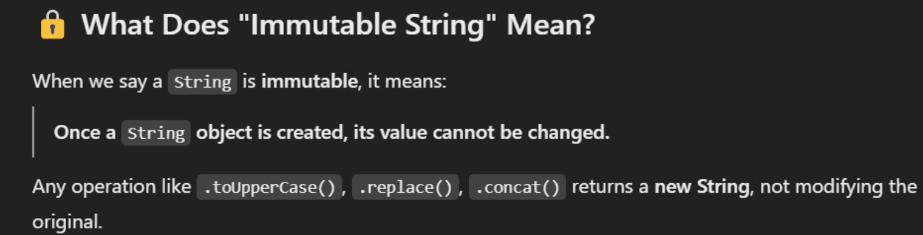

**String Buffer🡪**

* **They are mutable**
* **We don’t have concat method, we have append method**
* **We cannot directly use “ ” to create a string object, we need to create object using constructor(new).**
* **Equals method is not overridden in String Buffer.**

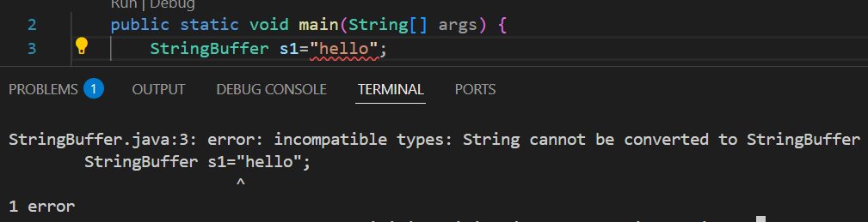

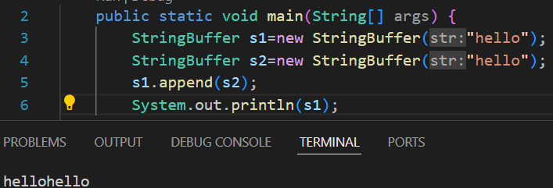

**String Methods**

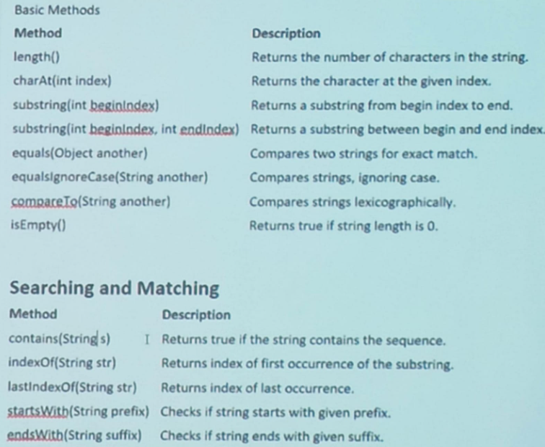

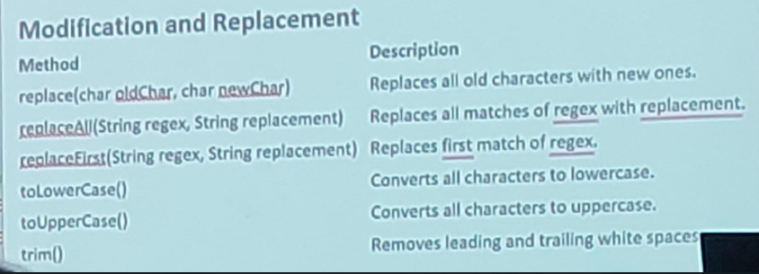

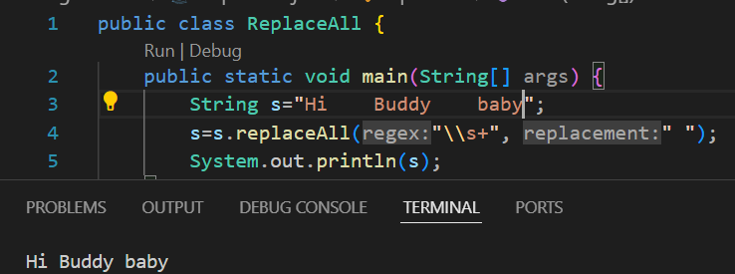

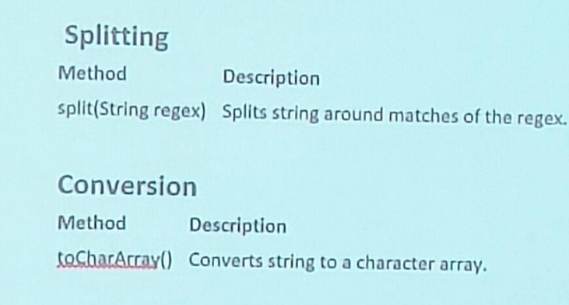

**Split**

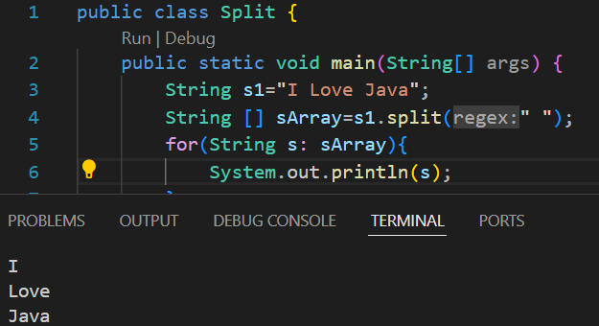

**Exception Handling**

**Error🡪** It will occur because of **Lack of System Resources.**

**Comparable Interface**

**Natural Sorting**

* Arrays.sort method internally calls compareTo method which is present in integer class if the array is of type int.
* Here array is of type book so we need to override compareTo(belongs to Comparable interface) inside book class.
* There is only one abstract non-static method present inside Comparable interface which is

public int compareTo(Object o){ } .

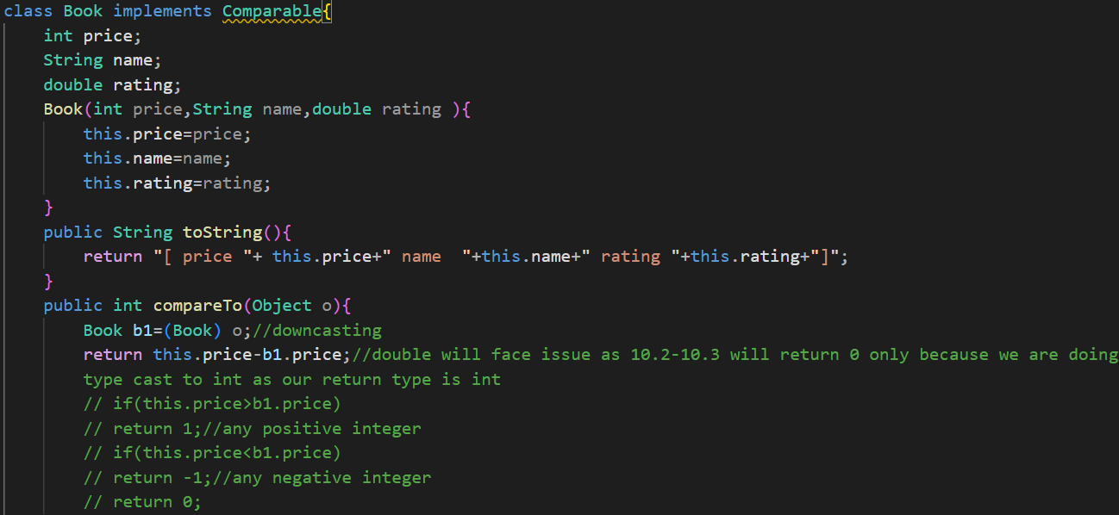

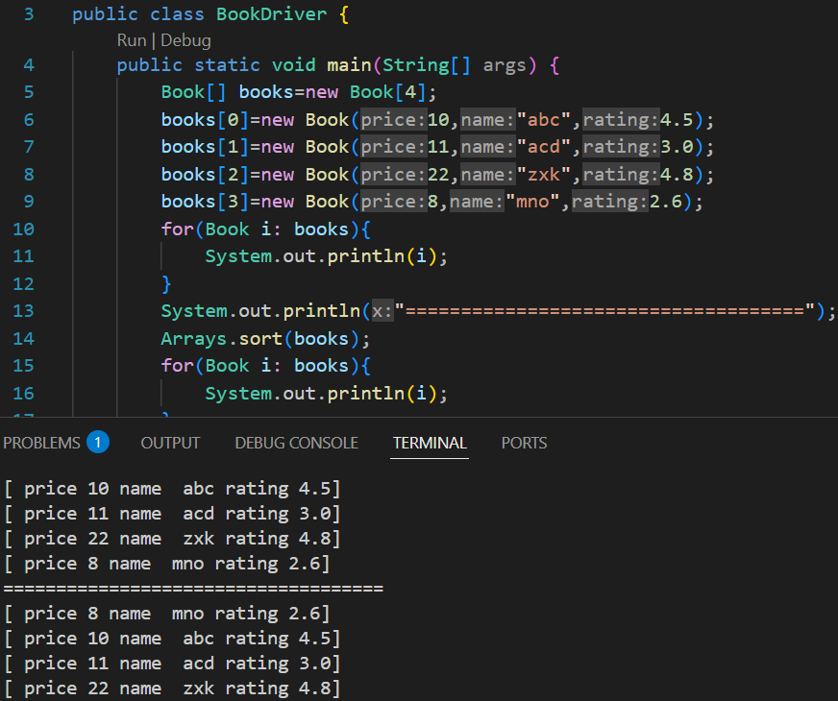

**For Double**

* We need to give datatype as **D**ouble because it is a method, it will not work on primitive data.

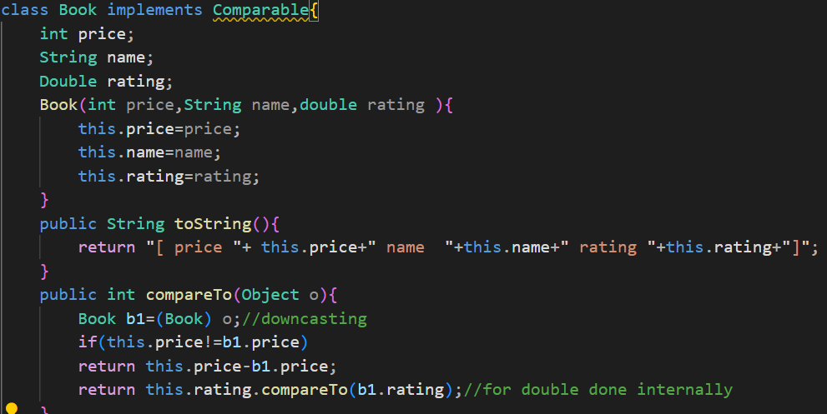

**Comparator Interface**

**How to achieve Custom Sorting**

* To achieve Custom Sorting we have to use comparator interface
* Inside comparator interface, we have one method🡪

int compare(Object o1, Object o2).

* We need to override this method.
* We will create another class, which implements comparator.
* If o1.rating>o2.rating return positive integer.
* If o1.rating<o2.rating return negative integer.
* If o1.rating==o2.rating return 0.

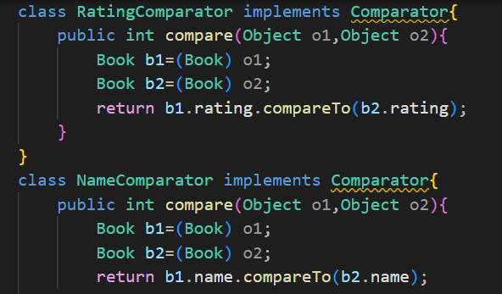

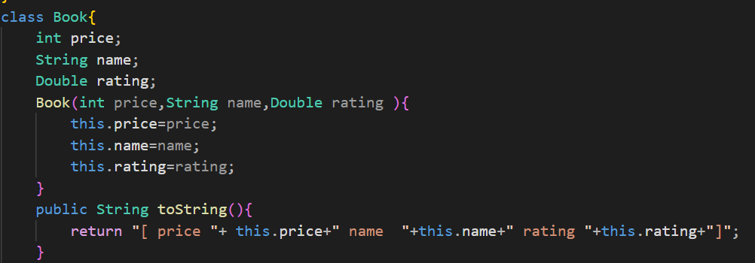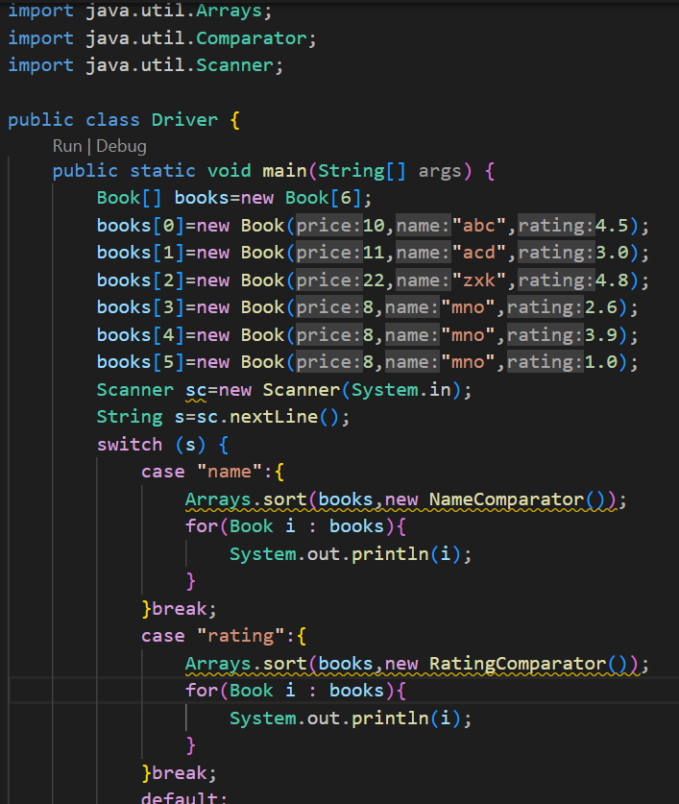

**Wrapper Classes**

* Inside collection we can store non-primitive data.
* Auto Boxing🡪Used to convert primitive data type to non-primitive data type.
* Auto Unboxing🡪Used to convert non-primitive data type to primitive data type.
* Primitive -> Non-Primitive(first letter capital)

1. byte -> Byte
2. short -> Short
3. int -> Integer
4. long -> Long
5. float -> Float
6. double -> Double
7. char -> Character
8. boolean -> Boolean

* Parent of Byte, Short, Integer, Long, Float, Double classes is Number class.

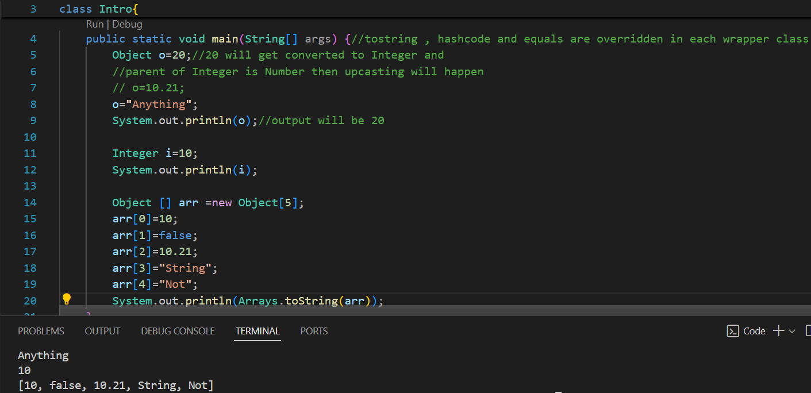

* If we use(==) to compare non-primitive data then it will check for the address.
* In wrapper classes if the range will be -128 to 127 it will not create a new object.

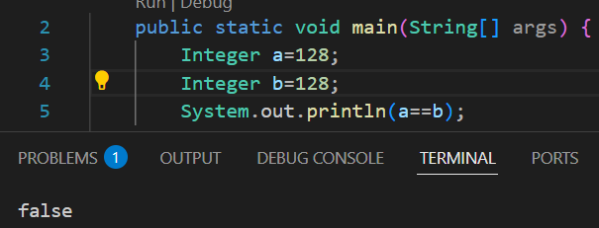

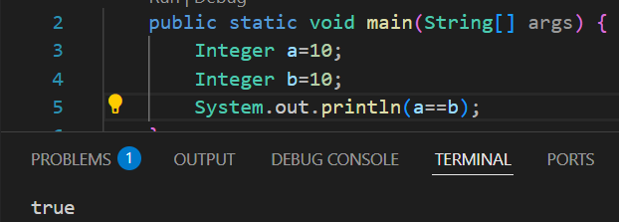

**Data Structures**

**Data🡪**Collection of raw facts.

**Data Structures🡪**Arranging the data in a systematic order to process the data in efficient way.

* Int , Object is also a data structure as we are storing data.

**Linear Data-Structures**

1. Arrays
2. Linked list
3. Queue
4. Stack

**1.Array**

* If we want to access any memory randomly in array we have the formula🡪

**[Base Address + (size of data type * index)]** 🡪 Constant time it will take for every storing and fetching.

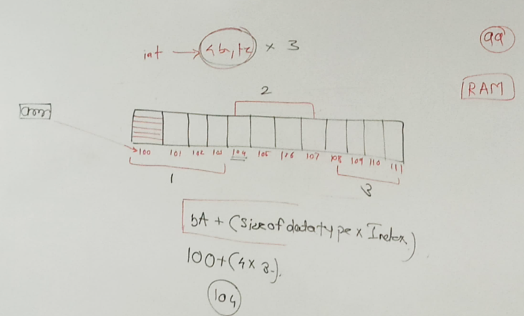

**2.Linked list**

* How to create a linked list🡪
  + 1. First create a node(object) that will contain two things data and address of next node.
    2. We need to create a class node to store both.
* We will have a **Head** variable that will store the address of first node.

**Reverse linked list**

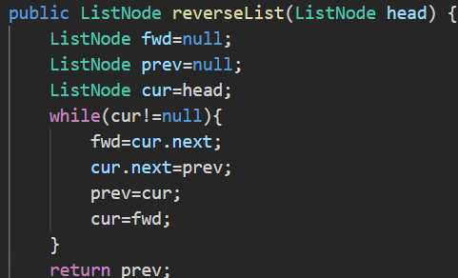

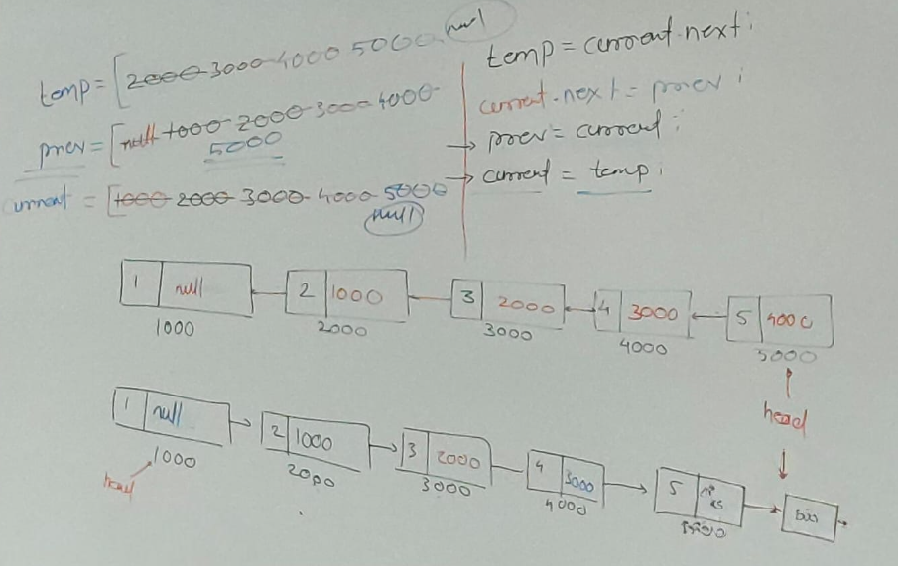

**3.Stack**

* It follows LIFO(Last in First out).
* Example🡪 Redo Undo
* Operations🡪 push, pop, peek.

**4.Queue**

NOTES

1. From uppercase to lower case +32 and vice versa.
2. Print is used to print the output in single line
3. Print cannot work when there is no argument e.g. System.out.print();

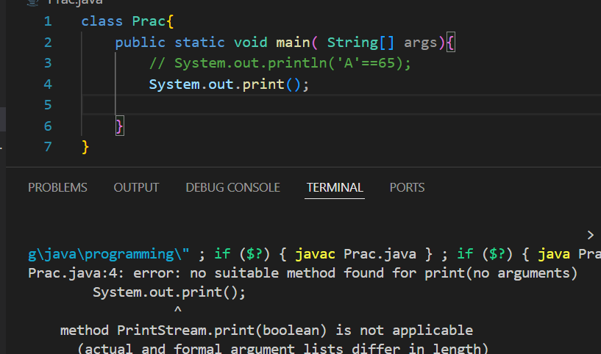

1. System.out.println() 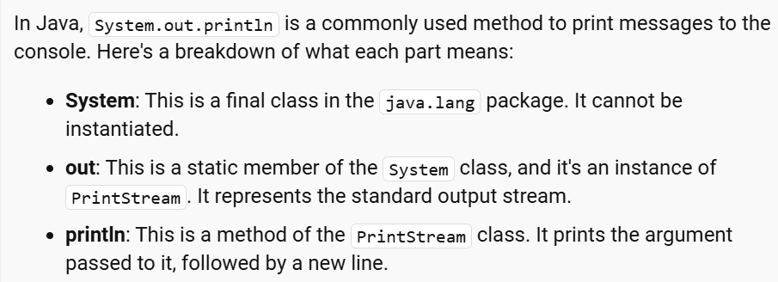
2. If we perform arithmetic operation on byte datatype then it will show error as arithmetic operations returns integer values.

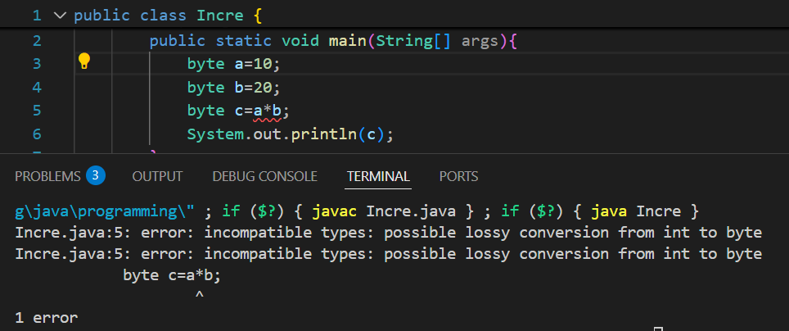

1. We cannot type caste Boolean to any other datatype or vise versa. 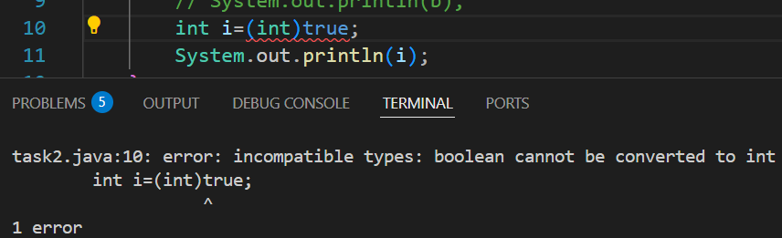
2. We can convert primitive datatype into non-primitive and vise versa using Rapper classes.
3. char ch=97; will not give error as it lies in the range of char(65535), no loss of data.
4. Inside printing statement we can call a method which will return some data (if the return type is void we cannot call it in printing statement).
5. If return type is other than void then return statement is mandatory.
6. Return statement should be the last statement inside the block
7. Whatever the classes are presented in lang package, they are automatically added.
8. Final keyword🡪
   * + If a variable is final we cannot change the value of the variable.
     + We cannot override a final method
     + If a class is final it cannot be inherited (Parent class cannot be final class).
9. Runtime binding🡪**Runtime binding** (also known as **dynamic binding** or **late binding**) is a concept in object-oriented programming where the method that gets called is **determined at runtime** rather than at compile time (method overriding).
10. **Nested Class🡪**

We need address to access nested class.

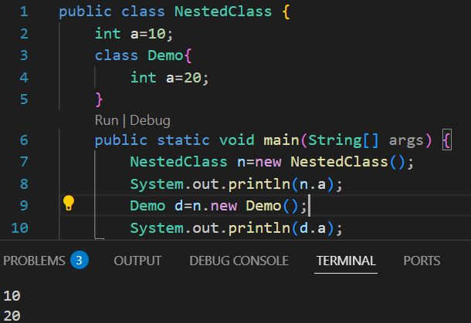

If the nested class is static we don’t require address as it consider itself as main class

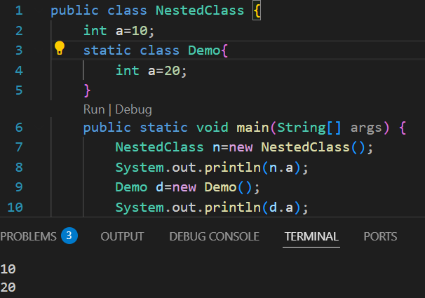

1. Size of non-primitive datatype**🡪 4byte(32 bits) or 8 byte(64 bits machine).**
2. **Var🡪** It is a reserved word (not a keyword because we cannot create an identifier name as keyword), it is used to create a variable that can store any type of data, it can only be used as a local variable.

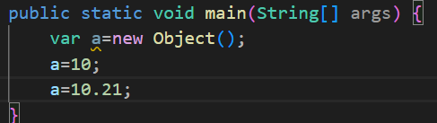

1. Static method cannot be an abstract method, as static method cannot be overridden.

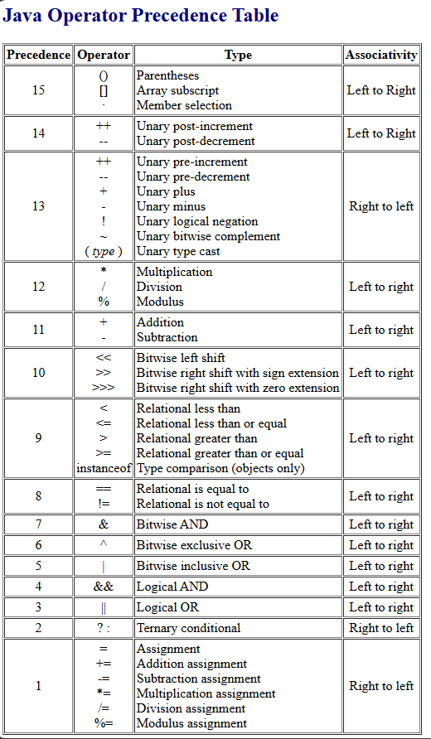

Ques-->

1. Diff. between abstract class and interface
2. 100% abstraction
3. Singleton design pattern
4. Functional interface
5. Marker interface
6. Interface onwards java 8 what all things are allowed
7. Polymorphism covariant return type
8. Inheritance diamond problem
9. Exception🡪try with multiple catch, **try with resource**
10. Diff. between throws and throw
11. When final will not be executed
12. Wrapper classes
13. How to convert string into primitive datatype
14. Object class🡪 toString, hash code, equals, clone
15. Contract between hash code and equals method
16. Class and object loading process
17. Comparable and comparator

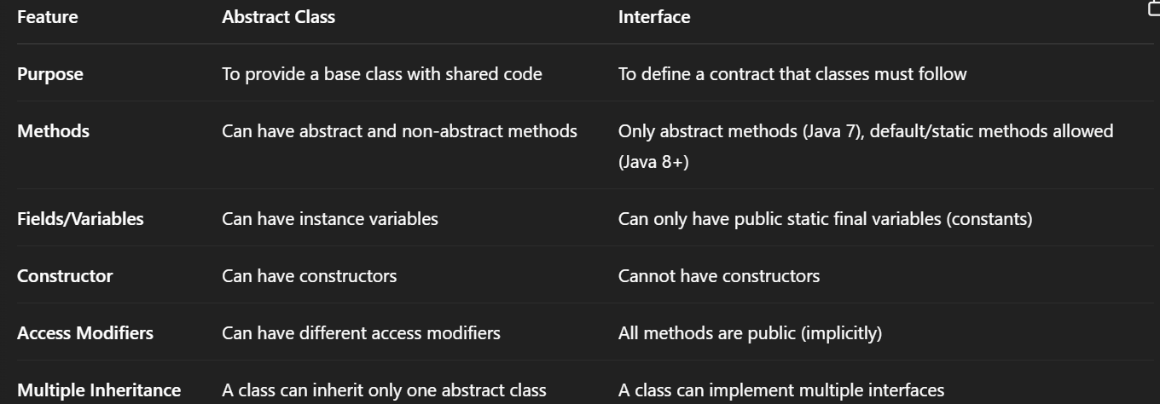

A **functional interface** is an interface that has **only one abstract method**. It **can** have multiple default or static methods (but still just **one** abstract method).

A **marker interface** is an interface **with no methods or fields** — it's just an **empty tag**. It’s used to **mark** a class for special behavior, usually handled by the **JVM** or some **framework**, based on whether the class implements that interface.

